The High Brilliance neutron Source (HBS): A project for a next generation neutron research facility
Thomas Brückel¹, Thomas Gutberlet¹, Johannes Baggemann¹, Junyang Chen¹, Tania Claudio-Weber¹, Qi Ding¹, Monia El-Barbari¹, Jingjing Li¹, Klaus Lieutenant¹, Eric Mauerhofer¹, Ulrich Rücker¹, Norberto Schmidt¹, Alexander Schwab¹, Jörg Voigt¹, Paul Zakalek¹, Yannick Bessler², Romuald Hanslik², Richard Achten², Fynn Löchte², Mathias Strothmann², Olaf Felden³, Ralf Gebel³, Andreas Lehrach³, Marius Rimmler³, Holger Podlech⁴, Oliver Meusel⁴, Frédéric Ott⁵, Alain Menelle⁵, and Mariano Andrés Paulin⁵
¹Forschungszentrum Jülich GmbH, Jülich Centre for Neutron Science (JCNS-2 & JCNS-HBS), 52425 Jülich, Germany
²Forschungszentrum Jülich GmbH, Central Institute of Engineering, Electronics and Analytics (ZEA-1), 52425 Jülich, Germany
³Forschungszentrum Jülich GmbH, Nuclear Physics Institute (IKP-4), 52425 Jülich, Germany
⁴Goethe University, Institute of Applied Physics, 60438 Frankfurt am Main, Germany
⁵Centre d' Etudes de Saclay, Laboratoire Léon Brillouin CEA/CNRS, 91191 Gif sur Yvette Cedex, France
Abstract. The High Brilliance neutron Source (HBS) is a project for a next generation neutron research facility, based on new concepts and recent technological advancements. As elementary processes it uses neither fission nor spallation, but instead low energy nuclear reactions in a very compact Target-Moderator-Reflector (TMR) assembly. Our facility design results in very efficient production of neutron beams with high brightness. Key features of HBS are: (i) very competitive instrument performance, (ii) comparatively low construction and operation costs, (iii) resilience, (iv) sustainability, (v) flexibility, (vi) accessibility and (vii) scalability. Here we present the basic layout of the facility, elaborate on the mentioned key features and report on the commissioning of a small test setup.

- Introduction
Large user facilities for research with neutrons, which offer instruments for neutron scattering, imaging, analytics, and nuclear physics or precision particle physics, are commonly based on fission in research reactors or spallation as the elementary processes to release neutrons from the atomic nuclei. In addition, there exist some smaller neutron sources, which use nuclear reactions after bombardment with electrons or rather low energy ions (mainly H⁺ - protons, or D⁺ at energies below 13 MeV). They are relatively small and are branded Compact Accelerator-driven Neutron Sources (CANS). Beams from such sources feature a neutron flux, which is orders of magnitude below the one of the larger user facilities. But CANS have an important local impact for specialized applications, training of users and method development. Japan hosts an entire network of CANS, organized in the Japan Collaboration on Accelerator-driven Neutron Sources (JCANS - http://jcans.net/ ) [1].
It is only in the last few years that an entirely new approach emerged to produce brilliant beams of cold, thermal, and epithermal neutrons. This approach is based on the same elementary process of low energy nuclear reactions but fully exploits the most recent technological developments in accelerator physics, target- and moderator technology, beam extraction, neutron optics and instrument design. Such facilities are labelled High Current Accelerator-driven Neutron Sources (HiCANS). While no HiCANS exists yet worldwide, several projects are being pursued in Europe aiming at the realization of such a facility. They are organized within the European Low Energy accelerator-based Neutron facilities Association (ELENA – http://www.elena-neutron.eu ). HiCANS will produce pulsed neutron beams of high peak brilliance, comparable to the ones from spallation sources or research reactors. They have the potential to replace the former network of research reactors in Europe, as affirmed in the recent position paper of the League of advanced European Neutron Sources (LENS - https://lens-initiative.org/ ).
At first sight it might be surprising that the rather inefficient process of low energy nuclear reactions can produce neutron beams of such high brightness. As elaborated in [2], the main reasons are as follows:
- A high current LINAC combined with a high-power target, resulting in a high reaction rate.
- An optimized proton pulse structure (pulse length and frequency) for the Target-Moderator-Reflector (TMR) assembly which feeds an adapted suite of instruments.
- An extremely efficient coupling of the thermal moderator to the compact target minimizing the loss of neutrons in the shielding.
- The use of highly efficient low dimensional “finger” moderators, which become part of the instrument, and deliver an optimized spectrum for the respective applications.
- A beam extraction optics starting very close to the moderator, so that a large phase space volume can be extracted and transported to the instrument when needed.
Due to these features, HiCANS have the potential to become the most efficient neutron facilities. Obvious savings with respect to spallation sources result from the low energy accelerator (MeV compared to GeV energy range) and reduced shielding. The most ambitious project for a HiCANS is being pursued at Forschungszentrum Jülich together with Helmholtz Zentrum Hereon and numerous partners from universities and research organizations. Here we report on the planned layout of the facility, labelled High Brilliance neutron Source (HBS - https://hbs.fz-juelich.de/ ) [3, 4], highlight the key features and report on the successful commissioning of a small test facility.
- HBS facility layout
Fig. 1 shows the proposed layout of the HBS facility; table 1 lists some key parameters. These were chosen in a conservative approach as a compromise between state-of-the-art technological feasibility, operational practicability, cost, and maximization of neutron yield. For example, the proton accelerator is designed to operate in normal conducting technology and avoids expensive superconducting cavities. Although the neutron yield would still increase beyond a proton energy of 70 MeV, for reasons of operational economy, a superconducting section would be required after the normal-conducting cavities, such as is implemented at the ESS. A peak current of 100 mA for the selected accelerator type is challenging but feasible. It can provide the 100 kW thermal power per target station that our Ta target can still digest. Similar arguments apply to the choice of the other parameters in Table 1.
Fig. 1. Schematic layout of the HBS facility showing the LINAC in an underground tunnel (dark grey), the distribution of the proton beam to three target stations located in three experimental halls and a sketch of the proposed reference instrument suite.

The LINAC in an underground tunnel feeds the high-energy beam transport (HEBT) line with the underground multiplexer. The latter consists of a kicker-magnet and a three-sector septum magnet to separate an interlaced pulsed proton beam. The multiplexer supplies three target-moderator-reflector (TMR) units in a biological shielding with proton beams of different pulse structures. The beams impinge on the thin, flat, horizontal Ta target from below. The instruments are grouped around these TMR units in three experimental halls. The TMR unit in Hall 1 (front right in Fig. 1) operates at 96 Hz. It is supplied with proton pulses of 167 μs length, resulting in 250 μs thermal neutron pulse length. This pulse structure fits to instruments like diffractometers or direct geometry spectrometers. Hall 2 (back right in Fig. 1) hosts instruments that require low wavelength resolution e.g., small angle scattering, reflectometer, or spin echo spectrometer, but also diffractometer requiring pulse shaping. Its TMR unit operates at 24 Hz with a proton pulse length of 667 μs equal to the thermal neutron pulse length. A 96 Hz TMR station in Hall 3 (left in Fig. 1) is optimized to provide neutrons with energies above the thermal range. It hosts mainly imaging and analytics instruments. Each TMR station offers 12 beam ports. Each beamline hosts just one instrument. It can be equipped with an individual moderator, thus providing a beam with optimised pulse structure and neutron spectrum for the respective application. A complete reference suite of 25 instruments for diffraction, large-scale structures, quasi-, high-resolution and inelastic scattering, analytics, and imaging has been worked out by a large group of specialists (see acknowledgements).

Table 1. Key parameters of the HBS
Accelerator [5] | protons of energy 70 MeV,  up to 100 mA peak current, beam duty factor of 6%, average proton beam power of 420 kW
High Energy Beam Transport (HEBT) [6] | multiplexer (kicker & septum magnet) distributing the beam to three TMR stations
Target [7] | Ta target with microchannel water cooling; 10x10 cm² active area;  designed for 100 kW power
TMR stations [8] | TMR 2 : 24 Hz (667 µs p-pulse))  TMR 1 & 3 : 96 Hz (167 µs p-pulse)  each TMR offers 12 beam ports
Moderators  [9, 10] | thermal moderator: light water  cold moderators: 1d «finger» moderators (solid mesitylene, solid methane, liquid para-hydrogen)
Instruments  [11-13] | full suite of 25 instruments for scattering, imaging, and analytics

- Key features of the HBS
Traditionally, neutron sources have been designed in such a way as to maximize the source strength. The number of free neutrons per second released by the source was a key performance indicator. For high flux sources, such as the HFR reactor of ILL or the FRM II reactor of MLZ, the source strength amounts to some ${10}^{18}n/s$. Such a high source strength leads to a large thermal flux of around ${10}^{15}n/{(s∙{cm}^{2})}$ in a larger volume around the core, ideally suited for applications like doping of Si single crystals or the production of certain radioisotopes. However, only a minuscule fraction of the neutrons produced arrive at the sample for beamline instruments. These have typical flux values between ${10}^{5}$ and ${10}^{10}n/{(s∙{cm}^{2})}$, depending on the required beam tailoring. Thus, for beamline applications, reactor or spallation neutron sources are not very efficient, as they produce many neutrons which end up in the shielding. HiCANS, and especially the HBS, are based on fresh thinking and are following different design criteria. The HBS maximises efficiency and source brightness, the relevant quantity for beamline experiments.
Employing time-of-flight techniques with strong neutron pulses, a compact design of the TMR unit including shielding, and optimal moderation and beam extraction, the peak brilliance of HBS of around ${10}^{13}n/{\left({cm}^{2}sÅsr\right)}$for para-H₂ at 0.3 nm wavelength, is comparable to some of the best neutron facilities, with clear exception of the flagship MW spallation sources. This performance is achieved with a source strength of about ${10}^{15}n/s$, three orders of magnitude smaller than in high flux reactors, which translates directly into cost savings for construction and operation. Due to the high source brightness, instrument performance at HBS compares well with some of the best existing instruments of their respective class. Table 2 presents some parameters for one selected instrument per instrument class.

Table 2. Some main parameters for a selection of instruments at HBS
Instrument type | Key features | Flux & resolution
Diffraction:  macro-molecular diffractometer | - 96 Hz target station  - p-H₂ moderator  - Selene optics  - beam spot at sample: $1x1 {mm}^{2}$ | 2∙10⁷ n/cm²s  ±0.19 deg div.
Large scale structures:  horizontal reflectometer | - 96 Hz target station  - p-H₂ moderator  - Selene optics  - length 7m | 10⁷ n/cm²s  5.6% - 1.0% wavelength resolution
Spectroscopy:  near backscattering spectrometer | - 24 Hz target station  - solid methane mod.  - primary flight path 85m | 7∙10⁶ n/cm²s  $5 μeV$ energy resolution
Imaging:  thermal neutron imaging | - 96 Hz target station  - water moderator  - high flux or high-resolution mode | 1∙10⁷ n/cm²s  $$L/D=100$$  in high flux mode

In addition to the efficiency, which translates into reduced costs, and the competitive performance of the instruments, the design of the HBS is characterized by several advantageous features:
- Resilience: HBS does not depend on the supply of regulated materials. It has a modular design. All components can be exchanged within hours or at most during a week maintenance time. To give some examples: The accelerator is driven by solid state amplifiers, which are redundant and can be easily exchanged in case of failure. For exchange of the target, a fully automated handling tool has been developed, which can pull the activated target out of the plug and insert a new target within a maintenance week. Same holds for the cold sources: a failure of a finger moderator affects only one instrument. During a maintenance week, the moderator insert can be exchanged from outside the TMR shielding.
- Sustainability: A concept for climate neutral construction is being worked out. Electricity from renewable energy sources is foreseen to drive the HBS accelerator. HBS does not use nuclear fuel and minimizes radioactive waste. The only heavily activated component is the target itself, about 5 kg of Ta. The remaining activity originates mainly from the decay of 182-Ta isotope with a half-life time of 114 days.
- Accessibility & flexibility: HBS will be licensed according to the German radiation protection ordinance (StrSchV) and not according to nuclear law. This facilitates access for users from science and industry enormously. The relatively modest shielding allows for very flexible setups.
- Scalability: HiCANS are scalable, with respect to the proton energy (by adding additional Drift Tube Linac elements), the number of target stations (due to their rather low cost), and instruments.
- JULIC neutron test platform
All critical components of HBS have been separately tested: (i) the accelerator is largely based on the MYRRHA (https://www.myrrha.be) design, (ii) cross sections for neutron release from different materials have been measured in absolute units [14], (iii) a prototype of the multiplexer has been realized and tested [6], (iv) the target has been tested up to the design value of $1 kW/{cm}^{2}$ at an electron beam facility, (v) “finger” moderators for all moderator materials under consideration were built and tested. However, in order to verify the interplay of all components, to improve the design and perform method development, a test station has been realized on the premises of the Nuclear Physics Institute of Forschungszentrum Jülich. The shielding of the TMR unit features an automated opening mechanism, so that the thermal moderator and reflector can be accessed and exchanged to optimize the TMR arrangement. The setup will also be used to test the automated exchange of an activated target. First beam on target was achieved on December 12, 2022. A photo of the test setup is shown in Fig. 2.

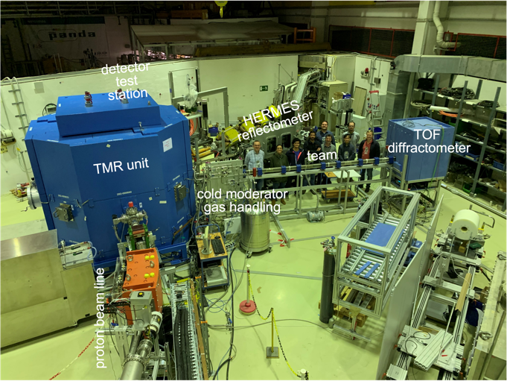
Fig. 2. Photo of the JULIC neutron test platform after first beam on target. The detector test station is not visible as it is located behind the TMR unit.
A proton beam of 45 MeV energy and a current in the 100 nA range was provided by the JULIC cyclotron, which normally serves as injector for the COSY cooler synchrotron. The proton beamline incorporates several diagnostic tools and a prototype of the three-septum magnet, a key element of the multiplexer designed for HBS. In contrast to the HBS design, where the proton beam impinges the target from below, the proton beam enters the TMR unit of the test facility from the side. The TMR shielding shown in the photo is only slightly smaller than the one of HBS, which will also have an octagonal shape of 4 m in width and 3.2 m in height. At the test platform, neutrons were released from a prototype Ta target having the size and fishbone microchannel structure of the HBS target. The target is embedded in a Polyethylene (PE) thermal moderator and Pb reflector structure. Three beam port channels were equipped with instrumentation. A detector test station with a pinhole collimator received neutrons from the thermal moderator. This beam port was used to test the prototype of the SONDE detector for the SKADI instrument [15] of ESS in time resolved acquisition mode. Another beam port hosts the HERMES ToF-reflectometer. It is provided by the Laboratoire Léon-Brillouin and was previously situated at the now shut-down Orphée reactor. Reflectivity of a neutron guide section was measured during the commissioning of the test setup. The third beam port is equipped with a ToF- diffractometer. A solid methane CH₄ cold source feeds neutrons into a 6.5 m long ⁵⁸Ni neutron guide of cross section 30 x 50 mm². At the end of the guide a ToF detector and an angular dispersive diffractometer is located in a shielding box made of borated PE. Fig. 3 shows the neutron spectrum measured at different temperatures of the cold source.

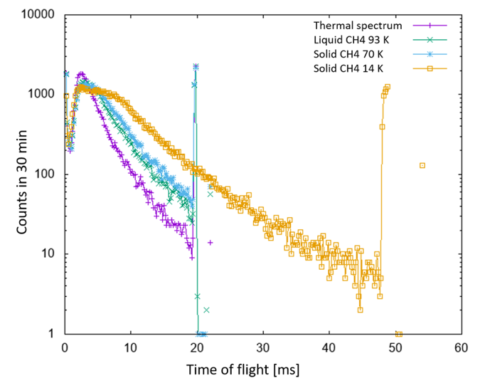
Fig. 3. Raw neutron spectra measured from the methane cold source at four different temperatures during the commissioning of the JULIC neutron test platform. The sharp peaks at the end of a TOF frame belong to the start of the next frame and result from the prompt pulse.
Clearly visible is the shift of the spectra towards longer ToF times, corresponding to longer wavelengths, with decreasing moderator temperature. Also visible is the double peak structure around thermal neutron energies. It comes from the fact that the wide neutron guide not only receives neutrons from the cold source, but also from the surrounding thermal moderator. This demonstrates that bispectral extraction is straight forward with such “finger” moderators. A clean cold spectrum can be obtained by placing a circular diaphragm in front of the neutron emitting surface of the cold moderator.
- Summary, conclusions, and outlook
Projects for High Current Accelerator-driven Neutron Sources (HiCANS) are being pursued at several places within Europe. The LENS and ELENA Associations work hand in hand to make these facilities happen. HiCANS promise to become the next generation of neutron facilities, not as flagship sources, but as a replacement for the former network of reactor-based neutron facilities in Europe.
The HBS project in Germany is the most ambitious of the ongoing projects in terms of accelerator energy and power, number of TMR units and instrument suite. Simulations show that HBS will feature very competitive instrument performance, at comparatively low construction and operation costs. Resilience and flexibility through modular design, sustainability, accessibility, and scalability are clear plus points of the HBS concept. All critical components of the HBS have been tested. Recently the JULIC neutron test platform has been commissioned which serves to prove the interplay of all components, to test automated target exchange procedures, to experimentally determine instrument performance in absolute units and to serve as testbed for further method development.
Having developed a design for all components of the HBS and experimentally demonstrated the functionality of all critical components, we are now finalizing the Technical Design Report (TDR) of the HBS. It will be published in 5 volumes: (i) Accelerator, (ii) Target Stations and Moderators, (iii) Instrumentation, (iv) Infrastructure and Sustainability and (v) Summary. The TDR will demonstrate the technical feasibility of the HBS and be a blueprint for the construction of the facility. As with all major projects, implementation of the HBS requires a long lead time. Construction of the full HBS, as described in the TDR, will require 10 years from start of funding. However, the facility could also be implemented in stages, with the first stage having only one TMR unit in operation no sooner than four years after funding.
In summary, the facility developments within the ELENA Association provide an opportunity and starting point for the rejuvenation of the European neutron ecosystem based on a network of smaller local CANS, HiCANS as national facilities, and the ESS as the leading flagship facility for completely novel experiments.

Acknowledgements Funding by the Innovation Pool Project of the Helmholtz Society and the Federal Ministry of Education and Research is gratefully acknowledged. We are thankful to many colleagues from different universities and research centres who have contributed to the design of instruments: R. Bewley, J. Fenske, M. Feygenson, C. Franz, H. Frielinghaus, M. Ganeva, A. Glavic, S. Jaksch, N. Kardjilov, G. Kemmerling, H. Kleines, Z. Ma, S. Mattauch, S. Pasini, K. Schmalzl, T.E. Schrader, W. Schweika, M. Strobl, E. Vezhlev, N. Violini, R. Zorn.

References
- Y. Kiyanagi, Eur. Phys. J. Plus 131, 132 (2016)
- T. Brückel, T. Gutberlet, S. Schmidt, C. Alba-Simionesco, F. Ott, A. Menelle, Neutron News 31, 13 (2000)
- T. Gutberlet et al., Neutron News, 31, 37 (2020)
- T. Brückel, T. Gutberlet (Eds.) Conceptual Design Report Jülich High Brilliance Neutron Source (HBS), Schriften des Forschungszentrum Jülich, General, Vol.8 (2020)
- H. Podlech et al., Conceptual Design of the Proton LINAC for the High Brilliance Neutron Source HBS, Proc. IPAC’19, Melbourne, Australia, 910-913 (2019)
- M. Rimmler, O. Felden, U. Rücker, H. Soltner, P. Zakalek, R. Gebel, T. Gutberlet, T. Brückel, J. Neutr. Res. 23, 143 (2021)
- P. Zakalek, P.-E. Doege, J. Baggemann, E. Mauerhofer, T. Brückel, EPJ Web of Conf. 231, 03006 (2020)
- P. Zakalek, J. Li, S. Böhm, U. Rücker, J. Voigt, E. Mauerhofer, T. Gutberlet, T. Brückel, J. Neutr. Res. 23, 185 (2021)
- T. Cronert, J.P. Dabruck, M. Klaus, C. Lange, P. Zakalek, P.-E. Doege, J. Baggemann, Y. Beßler, M. Butzek, U. Rücker, T. Gutberlet, R. Nabbi, T. Brückel, Physica B: Condensed Matter 551, 377 (2018)
- S. Eisenhut, M. Klaus, J. Baggemann, U. Rücker, Y. Beßler, A. Schwab, C. Haberstroh, T. Cronert, T. Gutberlet, T. Brückel, C. Lange, EPJ Web of Conf. 231, 04001 (2020)
- Z. Ma, K. Lieutenant, J. Voigt, T. Gutberlet, M. Feygenson, T. Brückel, Nucl. Instr. Meth. A, 1009, 165479 (2021)
- P. Zakalek et al, JPS Conf. Proc. 22, 011025 (2018)
- J. Voigt, S. Böhm, J.P. Dabruck, U. Rücker, T. Gutberlet, T. Brückel, Nucl. Instr. Meth. A, 884, 59 (2018)
- M. Rimmler, J. Baggemann et al., Nucl. Instr. Meth. A, 990, 164989 (2021)
- S. Jaksch, D. Martin-Rodriguez, A. Ostermann, J. Jestin, S.D. Pinto, W. Bouwman, J. Uher, R. Engels, H. Frielinghaus, Nucl. Instr. Meth. A, 762, 22 (2014)

Corresponding author: t.brueckel@fz-juelich.de

