Towards a conceptual design for the moderators of ARGITU: a preliminary neutronics study
Octavio G. del Moral, Miguel Magán, Fernando Sordo, Félix J. Villacorta and Mario Pérez
ESS-Bilbao, Bizkaia Technology Park, Laida Bidea, Building 207 B, Ground Floor, 48160 Derio (Spain)
Abstract. This work reports on preliminary calculations of potential low-dimensional moderators for the high-current accelerator-driven neutron source (HiCANS) ARGITU. Simulations start with the selection of materials, depending on the neutron energy range to be used for each instrument. Results evaluate the performance of water for thermal moderators to deliver neutrons for thermal instruments, whereas para-H₂ and solid methane have been analyzed to deliver cold neutrons. Additionally, alternative concepts like using hybrid moderators (water/liquid methane) or reduced-size cold moderators (reduced-size para-H₂) have been scrutinized for their use in bispectral instruments that require a wide range of intermediate neutron energies. The dimensions of the moderators have been refined to improve the neutron yield for the neutron wavelength range selected in each case. After that, a space-efficient layout has been proposed to implement four moderators next to the Be target, linked to a preliminary suite of instruments that these moderators would serve. Although the eventual selection shall consider both the final instrument suite and the phase space volume required for such neutron instruments (that defines their neutron optics features), the results presented here represent a qualitative step towards the conceptual development of the ARGITU neutron source.

- Introduction
High-Current Accelerator-driven Neutron Sources (HiCANS) represent a strategic move towards the development the next-generation neutron research facilities, oriented to mitigate the sudden decrease of available beamtime for neutron experiments. The HiCANS facility concept, by which neutrons are generated using a medium power accelerator (20-100 kW) that boosts a proton or deuterium beam towards a metal target through low energy nuclear reactions, are a new and efficient approach to produce beams with competitive neutron brilliance of thermal and cold neutrons, with lower construction and operation costs. Coordinated efforts to develop such kind of neutron sources are taking shape in several countries, like the HBS project in Germany and ICONE (formerly SONATE) in France, with recent developments and conceptual studies are taking place in Spain, Hungary, Italy and Sweden, all of them framed within the European Low-Energy accelerator-based Neutron facilities Association (ELENA).
ARGITU (“Light up” in Basque language) is the proposal for a neutron source in Spain. Located in the Basque Country, this facility belongs to the pioneer group of HiCANS proposed to keep Europe at their leading position in neutron science. Its main function will be to serve the local scientific community and enable everyday science aimed to address current major societal challenges related to new materials for computing and digital world (e.g., quantum computing, new sensors), energy and climate (e.g. new types of Li and Na batteries, fuel cells, hydrogen storage), and health (e.g., drug delivery, molecular dynamics in biosystems). Simultaneously, the facilityis intended to train the next generation of neutron scientists, since maintaining a broad community is essential to promote scientific discussion and address such new challenges through neutron science.
The conceptual design of ARGITU consists of a proton accelerator that delivers pulsed beams of duration 1.5 ms at a frequency of 30 Hz. The proton beam (peak current 32 mA), reaching a final energy up to 31.5 MeV, by means of a 4-segment radiofrequency quadrupole and a 2-tank drift-tube linear accelerator (linac) hits a cooled beryllium target producing neutrons through stripping ⁹Be(p,n) reactions. Similar concepts have been validated in existing target designs for other compact sources,, and can be scaled for HiCANS, which delivers a qualitative higher beam power. Neutrons generated are reflected by a beryllium reflector. Thermal and cold neutrons are usually obtained by means of thermalization processes occurring within the moderators., A limited number of instruments at one target station are allowed, due to the worsening of the efficiency of the reflector with the increasing number of holes in such reflector to accommodate the neutron beam ports to integrate neutron scientific instruments. In ARGITU, every target station can deliver neutrons up to 4 instruments. This work intends to provide a preliminary picture of the moderators that can be implemented on the first target station of ARGITU.
- Methods
The neutron yield of beryllium thick targets was simulated using MCNP6.2 code utilizing the nuclear data ENDF-B/VIII for neutrons (S(α,β) for thermal scattering) and ENDF-B/VII for protons. Tallies are placed to count neutrons going through the viewed surface of the moderator. At striping reactions, incident particles (i.e., protons) combine with the target nucleus (⁹Be) and neutrons are generated as subproduct of the original particle with almost the same momentum and direction. SuperMC software is used to convert CAD geometries to MCNP format and built up the model.,
Beryllium is a very suitable option as a target material due to its good heat conduction, high melting point and high neutron yield at energy region up to 50 MeV. Moreover, although beryllium is the chosen material for the ARGITU target, additional simulations including ⁷Li(p,n) stripping reactions were carried out as a benchmark for validation of the results. In the calculations, thicknesses of 2.23 cm for Li (not in the literature) and 0.7 cm for Be are sufficient to stop a 31.5 MeV proton beam.
Results confirm a good agreement between nuclear data cross sections and experimental results at the same incident proton energy (Figure 1).,, A Be target hit by a proton beam of 31.5 MeV energy leads to an unmoderated neutron yield of 2.1×10¹¹ neutrons/μC (1 Coulomb = 6.24×10¹⁸ protons) with a wide energy distribution from 1 keV to 31.5 MeV with an average energy of 215 keV. Results for 3 MeV protons also match previous results in literature (in this case, 0.3 cm of Li is enough to stop protons of 3 MeV), which would lead to get 1.65×10⁹ neutrons/μC for lithium and ~5×10⁸ neutrons/μC for beryllium. In summary, results are harnessed to validate that the total neutron yield at these energy levels can be reproduced by MCNP simulations with an appropriate accuracy using nuclear data cross sections without nuclear models.
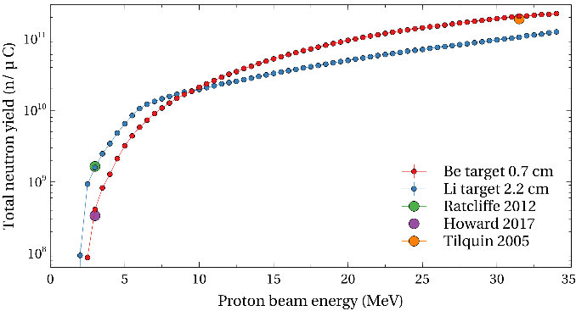
Fig. 1. Neutron yield for low-energy proton beam reactions (p, n) using Li and Be targets, and comparison with referenced literature [16,17,18]
Due to stripping reaction and target shape, the neutron spectra are not isotropic. Most of the neutron flux follows the original proton beam path, which is the privileged direction with the most energetic neutron spectra. This marked angle-dependence warn against placing neutron beam extraction, NBEX, for thermal and cold neutron applications at low angles.
- Results and Discussion
  - Moderators: materials and neutron yield
The scalability of HiCANS in order to maximize the performance of neutron scientific instruments allows the possibility of a dedicated and customized moderator for each one of them. Moreover, one of the advantages of neutron sources with moderate power (below 100 kW) is that the neutron moderators and the neutron optics can be located very close to the target (the damage by irradiation estimated makes this affordable). This allows the integration of moderators attached to the neutron beam extraction, NBEX, and this moderator-NBEX assembly to be close to the target.
The neutron moderation process is based on the collision of neutrons with a material (moderator) that brings the average energy of neutrons stemming from the target to an appropriate energy spectrum useful for neutron scattering experiments. At this stage of the ARGITU development, four possible thermal and cold moderating materials are being proposed: water at room temperature, liquid methane at 100K, solid methane at 22K and parahydrogen.
- Water (300 K). It is a common thermal moderator: it is a very effective thermal moderator due to its high hydrogen density (111 g/dm³) which have a good neutron cross section.
- Methane (solid at 22 K and liquid at 100 K). it has a high hydrogen density (106 g/dm³), due to its 4 hydrogen atoms per molecule. It has a low absorption rate for neutrons and many low-energy excitation states to scatter them with a short free path. Depending on the temperature, it is a fairly good candidate for cold or bispectral instruments.
- Para-H₂ (~20 K): Despite being pure hydrogen, the hydrogen population (70.8 g/dm³) is lower than the hydrogenous materials mentioned above. Moreover, it has quite long neutron free path. However, it is ideal to enhance the population of cold neutrons well beyond the thermal energies.
Initially, a first approach will consist of simulating one neutron beamline with a single cylindrical moderator (radius 2.5 cm) normal to the Be target surface, i.e., at an angle of 135º with respect to the proton beam (see inset of Fig. 2).
The use of a thin water pre-moderator has been rendered necessary to slow down neutrons before they reach into the moderator and the NBEX, increasing in turn the moderator efficiency for all cases under study. This element, wrapping the moderator but slightly detached from it, consists of a room temperature water layer. An optimum thickness for the pre-moderator is between 1 cm to 2 cm (see Fig. 2). Thicker pre-moderators visibly reduce the outgoing neutron flux.
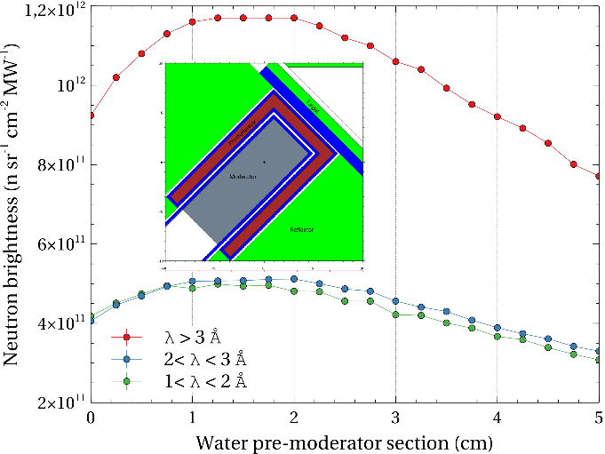
Fig. 2. Neutron brightness vs pre-moderator thickness for several energy ranges (Inset: MCNP moderator model, showing the configuration of the water pre-moderator).
Figure 3 shows the dependence of neutron flux on the moderator radius at certain neutron energy ranges for the four moderating configurations. Water and para-H₂ provide an optimized flux with a radius around 1 cm. On the other hand, methane moderators display a maximum between 1.5 and 2.5 cm (diameter: 3-5 cm). In this preliminary study, the section of the moderator has been fixed to 5 cm diameter, although a future redesign of the neutron instrument suite is envisioned as soon as the conceptual design of the instrument suite takes shape.
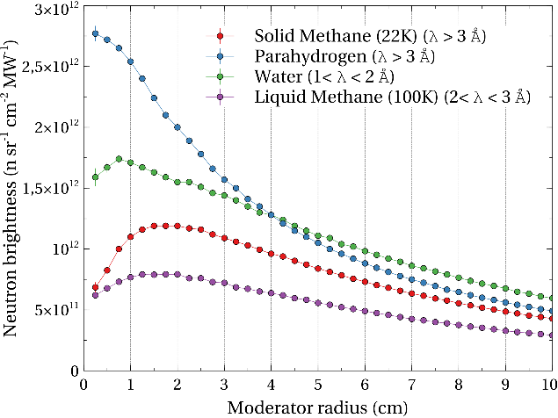
Fig. 3. Neutron brightness vs moderator section (radius).
The next step is to analyze the optimum thickness (height of the cylinder or length in the direction normal to the target surface) for the moderator materials considering the previous layout of one single neutron line at 135º. Every moderator requires to find a maximum of performance. A too thin moderator does not clash enough with neutrons to slow them down and a too thick one would increase the portion of absorbed neutrons reducing the effective flux.
Room temperature water is the suitable candidate for thermal neutron moderator and just requires 3 cm to get an unmatched performance, as shown in Figure 4a for neutrons with wavelengths between λ = 1 Å and λ = 2 Å.
On the other hand, parahydrogen has been demonstrated to be an ideal cold moderator to increase the flux of cold neutrons. Considering the yield of cold neutrons with λ > 3 Å displayed on Figure 4c, the best performance is achieved with a long moderator (≈ 13 cm), very similar to the concept of “finger moderator” proposed for cold instruments at the HBS.[8]
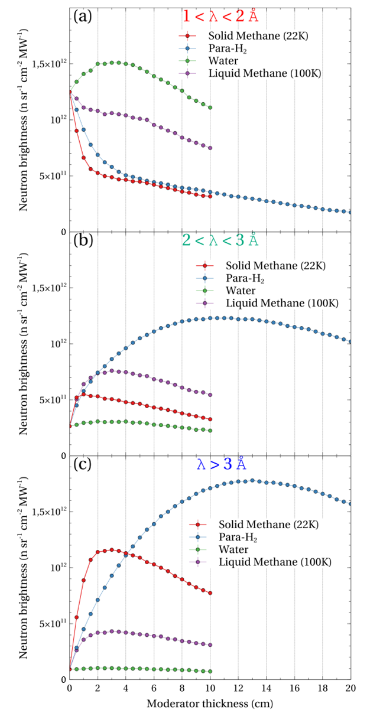
Fig. 4. Neutron flux as a function of moderator length (thickness) for the 4 moderators proposed, at different neutron wavelength ranges: (a) 1-2 Å; (b) 2-3 Å; and (c) >3 Å. The moderator section was fixed to 5 cm diameter in all cases.
Solid methane shows a good behavior to deliver cold neutrons with a thickness of 2-3 cm (better than para-H₂ with the same thickness up to 4 cm, see Fig. 4c). This must be taken into consideration in cases where there are dimensional restrictions.
Finally, liquid methane shows an overall good performance in the thermal-bispectral range (between λ = 1 Å and λ = 3 Å, see Figures 4a and 4b).
Figure 5 shows the spectra in the thermal and cold range delivered by these moderators at their best performance, i.e. with their optimized thickness. Results confirm the suitability of 3 cm-thick water (1 cm pre-moderator plus 2 cm of moderator) as thermal moderator and 13 cm-thick para-H₂ as the chosen cold moderator, keeping 3 cm-thick solid methane as an adequate alternative in case of geometrical/dimensional restrictions.
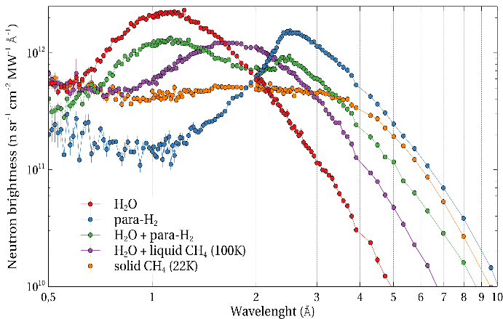
Fig. 5. Neutron spectra for several moderator materials at their optimized thickness. All moderator materials include a pre-moderator consisting of a 1 cm thick water layer.
Furthermore, additional calculations have been carried out using a combination of two moderating materials to achieve a good performance at intermediate wavelengths. The purpose is to find a suitable moderator for bispectral capabilities. Two options have been considered (the final ratio between the two moderating materials can be tuned up regarding the relative viewed areas of both moderators):
- Reducing the diameter of the cold para-H₂ moderator to 60% of the neutron line (3 cm), a bi-spectral moderator can be generated with a good flux yield at thermal and cold ranges, slightly peaking at 1.1 Å and at 2.4 Å.
- Using a water moderator (3 cm thick) and adding liquid methane (0.8 cm thick) yields good neutron spectra peaking at around 1.6 Å, the neutron flux is larger for wavelengths between water and para-H₂ peaks, which could be of interest to some kind of experiments.
  - Moderators: layout
The target and moderator shall be integrated in a beryllium reflector to increase the neutron moderation efficiency. The target-moderator-reflector (TMR) system, hosted within a cylindrical stainless-steel vessel, will confine the neutron stream in a very small volume (see Figures 6a and 6b).
When a 31.5 MeV proton beam impinges on the beryllium plate a cloud of neutrons fills the target vessel and clash within the reflector. Figure 6c focuses on neutrons at the epithermal range and below (E < 400 meV) because they can be more efficiently moderated to get useful thermal and cold neutrons. Neutrons above this energy are too fast and could not be moderated in this small target vessel.
Figure 6d shows the neutron flux for several energy ranges. Results reveal that there is a wide angular range with a very predominant presence of fast neutrons with E > 400 meV around the normal of the target surface (135º±30º with respect to the proton beam). This angular range should be avoided in the selection of the final location of the moderators and NBEX of the instruments since these high energy neutrons can go through the beam ports and reach the sample and the detectors, conveying background issues. For this reason, the four instrument beamports must be distributed at angles outside this range.
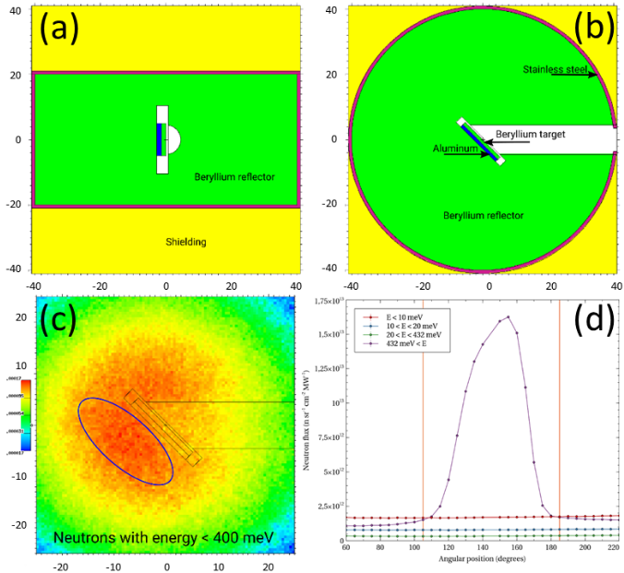
Fig, 6. (a) Side view and (b) top view of the MCNP model for ARGITU TMR; (c) and neutron cloud with energies lower than 400 meV; (d) Integrated neutron flux at several energy ranges depending on the angle with respect to the proton beam.
The selection of the instrument suite shall be made jointly with the local user community, and a final consensus is still to be reached. In any case, workhorse neutron scattering instruments, such as diffractometers, instruments to investigate large-scale structures (SANS and reflectometers) and spectrometers, share similar characteristics within a somewhat wide range, including the useful neutron wavelength range. In any case, any potential selection should consider:
- focusing on the neutron scattering techniques that could be more profitable for the scientific community.
- the technical limitations due to the moderate flux delivered by the source.
Based on the demands of the local scientific community, four instruments can be tentatively envisioned to be implemented in the target station of ARGITU: a thermal powder diffractometer, a single-crystal diffractometer (bispectral), a small angle scattering (SANS) instrument (cold), and a horizontal reflectometer (cold).
Figure 7 shows a proposed set-up of the four moderators and the four beamports for the four tentative neutron scientific instruments. Instrument moderator-beamports 1 and 3 (single crystal diffraction and neutron reflectometer) are above the equatorial plane (+Z) and beamports 2 and 4 (powder diffraction and SANS, respectively) are below the equatorial plane (-Z).
Fig. 7. MCNP layout for ARGITU concept of 4 neutron beam extraction lines (NBEX) designated for 4 different instruments (SANS, Reflectometer, Powder Diffractometer and Single Crystal Diffractometer)
Figure 8 depicts the neutron spectra of the four moderators at their downstream end surface (i.e., at the entrance of their respective NBEX). Results confirm a similar spectral shape and intensity values, with respect to the previous results for stand-alone moderators, except for the expected and intuitive slight reduction of the final neutron flux. Needless to say, the spectra provide a very stimulating result towards the development of the future neutron instrument suite of the ARGITU neutron source.
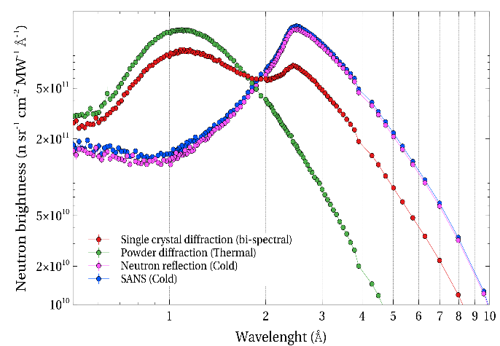
Fig. 8. Spectra of the four moderators at the moderator downstream end surface.
- Conclusions
This work presents preliminary neutronics calculations for candidate moderators to be integrated in the target station of the ARGITU high-current accelerator-driven neutron source. After a first approach to the neutron yield of the Be target hit by the proton beam, next steps were oriented to find the best configuration, geometry, layout for 4 moderators. All moderators include a small wrapping layer of water (1 cm thick) that acts as a pre-moderator, providing a significant improvement in the efficiency of the neutron moderation, and thus their eventual neutron yield.
Results suggest that a long cylindrical (one-dimensional) para-H₂ moderator, with height of 13 cm is the ideal choice to deliver cold neutrons with λ > 3 Å, ideal for cold instruments like a SANS or a neutron reflectometer. Solid methane of 2-3 cm long is also a good candidate, that can be considered in, e.g., locations with particular spatial restrictions.
A 3 cm-long water moderator is considered as a suitable thermal moderator that can be integrated in, e.g., a thermal powder diffractometer.
Finally, a reduced-size cold moderator (like para-H₂ with smaller cylinder diameter of 3 cm diameter),,, presents superior neutron yield at larger energy range for implementation in bispectral instruments (like, e.g., a single crystal diffractometer) compared to the hybrid thermal/cold (water/liquid methane) concept, that is only superior at a narrow wavelength range around λ ≈ 2 Å.
This study is ongoing and additional calculations are being carried out. The final design of the moderator will need to consider strong coupling between the moderator and the optics of the instrument that serves. However, as a first approach. ARGITU will enable the production of cold and thermal neutrons up to an adequate flux for the the performance of neutron scattering experiments, which will surely represent a significant stimulus for the local users community in the field of neutron science.

References

Corresponding author: fjimenez@essbilbao.org
T. Gutberlet, U. Rücker, E. Mauerhofer, P. Zakalek, T. Cronert, J. Voigt, J. Baggemann, J. Li, P. Doege, S. Böhm, M. Rimmler, O. Felden, R. Gebel, O. Meusel, H. Podlech, W. Barth & T. Brückel, Neutron News, 31, 37 (2020).
F. Ott, A. Menelle,C. Alba-Simionesco, EPJ Web Conf., 231 01004 (2020).
http://www.elena-neutron.eu
M. Pérez, F. Sordo, I. Bustinduy, J. L. Muñoz, F. J. Villacorta, Neutron News, 31, 19 (2020).
I. Bustinduy, F.J. Bermejo, Phys. Procedia, 60, 157 (2014)
D.V. Baxter, J.M. Cameron, V.P. Derenchuk, C.M. Lavelle, M.B. Leuschner, M.A. Lone, H.O. Meyer, T. Rinckel, W.M. Snow, Nucl. Instrum. Meth. Phys. Res. B, 241, 209 (2005)
F. Maekawa, M. Harada, K. Oikawa, M. Teshigawara, T. Kai, S. Meigo, M. Ooi, S. Sakamoto, H. Takada, M. Futakawa, T. Kato, Y. Ikeda, N. Watanabe, T. Kamiyama, S. Torii, R. Kajimoto, Mi. Nakamura, Nucl. Instrum. Meth. Phys. Res. A, 620, 159 (2010)
T. Cronert, J. P. Dabruck, P. E. Doege, Y. Bessler, M. Klaus, M. Hofmann, P. Zakalek, U. Rucker, C. Lange, M. Butzek, W. Hansen, R. Nabbi, T. Bruckel, J. Phys.: Conf. Ser., 746 012036 (2016)
G. Muhrer, Nucl. Instrum. Meth. Phys. Res. A. 664, 38 (2012)
MCNP Version 6.2 Release Notes, Los Alamos National Laboratory report LA-UR-17- 29981 (2018)
D.A. Brown, et al. 2018 Nucl. Data Sheets, 148, 1 (2018)
M. B. Chadwick et al., Nucl. Data Sheets, 107 2931 (2006)
Y. Wu, Fusion Sci. Technol., 74, 321 (2018)
Y. Wu, J. Song, H. Zheng, G. Sun, L. Hao, P. Long, L. Hu, Ann. Nucl. Energy, 82, 161 (2015)
F. Fernandez-Alonso, D. Price, Neutron Scattering - Fundamentals 49 (2013).
W. B. Howard, S. M. Grimes, T. N. Massey, S. I. Al-Quraishi, D. K. Jacobs, C. E. Brient, J. C. Yanch, Nucl. Sci. Eng., 138, 145 (2001)
N. Ratcliffe, R. Barlow, A. Bungau, R. Cywinski, R. Edgecock, Conf. Proc. C, 1205201, 4154 (2012)
I. Tilquin, P. Froment, M. Cogneau, Th. Delbar, J. Vervier, G. Ryckewaert, Nucl. Instrum. Meth. Phys. Res. A, 545, 339 (2005)
A.R. Páramo, F. Sordo, J.M. Perlado, A. Rivera, J. Nucl. Mater. 444, 469 (2014).
https://www.lens-initiative.org/wp-content/uploads/2021/02/LENS-Report-on-Low-Energy-Accelerator-driven-Neutron-Sources.pdf
L. Zanini, K.H. Andersen, K. Batkov, E.B. Klinkby, F. Mezei, T. Schönfeldt, A. Takibayev, Nucl. Instrum. Meth. Phys. Res. A, 925 33 (2019).
M. Magán, F. Sordo, L. Zanini, S. Terrón, A. Ghiglino, F. Martínez, J.P. de Vicente, R. Vivanco, J.M. Perlado, F.J. Bermejo, F. Mezei, G. Muhrer, Nucl. Instrum. Meth. Phys. Res. A, 729, 417 (2013).
K. H. Andersen, M. Bertelsen, L. Zanini, E. B. Klinkby, T. Schonfeldt, P. M. Bentley, J. Saroun, J. Appl. Cryst., 51, 264 (2018)

