Endurance – Modernisation of the instrumentation suite at the Institut Laue-Langevin
Charles Dewhurst¹, and Andreas Meyer¹
¹Institut Laue-Langevin, 71 avenue des Martyrs, 38042 Grenoble, France
Abstract. Endurance encompasses more than 30 new or upgraded instrument and infrastructure projects, rolled out over 8 years between 2016 and 2023. Many new or upgraded instruments have already been deployed and are in user-operation including: the fission-fragment gamma ray spectrometer, FIPPS; the upgraded cold-neutron TOF spectrometer IN5; new thermal TOF spectrometer PANTHER; and a second protein crystallography station, DALI. The D3 hot-neutron diffractometer and IN20 thermal triple-axis spectrometer have been upgraded while new and additional detectors for the SANS instruments D11 and D22 have been installed. The D16 cold-neutron diffractometer has been fully modernised and new cold-neutron imaging instrument, NeXT, has been installed. Delivering a full suite of modernised instrumentation is dependent on the renewed in-pile beam extraction, H1-H2, new H24 (thermal) and H15 (cold) neutron guides and the in-house development and manufacture of critical technologies such as neutron detectors, monochromator optics and polarisation components. The new H24 guide provides dedicated end-of-guide positions to the upgraded D10+ single crystal diffractometer, IN13 backscattering instrument and the new XtremeD powder and single-crystal diffractometer. H15 will accommodate a substantially upgraded D(00)7 polarised diffuse scattering and spectroscopy instrument while D11 will be rebuilt and relocated with an optically cleaner collimation. Two additional end-of-guide positions are available for new instrumentation: The SHARP+ cold-neutron TOF spectrometer and a 4th SANS instrument, SAM. The success of Endurance will provide users with a fully modernised suite of world-class instruments.

- Introduction
The ILL has maintained its position as international leader in neutron science by paying constant attention to its capacity for innovative engineering and through the construction of ever more powerful instrumentation. To this end, the Millennium Programme [1] has been succeeded by Endurance [2]. The first phase of Endurance began in 2016 with a particular emphasis on the replacement of the H24 thermal-neutron guide and associated instrumentation. In 2019 the ILL Associates agreed to fund a second phase of Endurance in full, thus allowing the complex and interdependent H15 cold-neutron guide and instrument projects to go ahead. For each phase of Endurance an external and independent dedicated instrument subcommittee was convened in order to advise the ILL management and ILL’s scientific council as to the prioritisation of projects. Many Endurance projects that are independent of large infrastructure modifications such as neutron guides have already been delivered. With the replacement of key neutron guide infrastructure during the recent long shutdown we have delivered the large interdependent suite of instrumentation on the new H24 neutron guide and are installing the new H15 guide and instruments.
Endurance is an ambitious programme that has required careful planning to ensure that the construction schedules for the new instruments and critical infrastructure remain coherent with the reactor maintenance programme and operating cycles. In 2020, the ILL launched the multiannual ILL20-23 programme, which combines a major upgrade of the instrument suite (Endurance), safety implementations and maintenance operations to the reactor. The ILL20-23 project involved a master resource-loaded schedule for coordinating instrumentation work and reactor activities whilst securing a maximum of reactor cycles for our users.
During the H1-H2 long shutdown from October 2021 to February 2023 we have rolled out the build of our modernised infrastructure and instrument suite under the Endurance programme and in parallel with major maintenance, security and safety work on the reactor. The new H24 guide and instrument suite has been completed and has begun commissioning with the reactor restart on 27th February 2023. The H15 guide and associated instrumentation is on time for delivery in the second half of 2024. The first neutrons of 2023 have allowed us to perform important radioprotection validation of the new installations and the scientific commissioning of new or upgraded instrumentation. Gold-foil activation measurements and the first commissioning data from the new instruments have validated the performance of the new guide installations.
We are now ready to welcome the return of user experiments.

- Endurance
  - Endurance phase 1 (2016 – 2018)
The first phase of Endurance has already seen the delivery and entry into user operation of the new fission-fragment gamma ray spectrometer FIPPS [3], the upgraded IN5 cold time-of-flight (TOF) spectrometer [4], upgraded IN20 thermal triple-axis spectrometer (TAS), new thermal TOF spectrometer PANTHER and an upgraded D3 hot-neutron diffractometer to allow for efficient measurement of hydrogen-containing liquid samples [5]. Meanwhile, after a long and complex cryogenic project the SuperSUN source of ultra-cold-neutrons [6] has begun commissioning with the aim to produce the highest densities of UCN’s and allow science to begin on the PanEDM experiment. The BASTILLE and NESSE infrastructure projects have continuously delivered software for data treatment and analysis and new sample environment capabilities throughout Endurance.
The ‘backbone’ of Endurance 1 is the Chartreuse project involving the renewal of the H24 thermal neutron guide and the upgrade of the D10+ single crystal diffractometer, IN13 (CRG – collaborative research group) backscattering spectrometer [7] and a new extreme conditions powder and single crystal diffractometer, XtremeD (CRG). The ‘Chartreuse’ project has now finally been delivered with the completion of the H1-H2 shutdown in February 2023 and is described in Section 3.1.
  - Endurance phase 2 (2019 – 2023)
The second phase of Endurance had its tentative scope and budget set during 2017 with review and recommendations by a dedicated Instrument Subcommittee and endorsement by the Scientific Council. In a first round of funding for Endurance 2 we were able to rapidly construct detectors for the SANS instruments D22 and D11. A second protein crystallography station, DALI, was installed on a modified H141 guide (ex IN11) while the secondary spectrometer of the D16 cold-neutron diffractometer has also been upgraded including a new wide-angle detector [8]. The neutron imaging facility, NeXT, entered the user programme in 2020 [9] and has now seen a full re-build of the imaging instrument backbone allowing for state-of-the-art imaging and a second (monochromatic) imaging station, MOTO to be operational in 2024.
The ‘lion’s share’ of Endurance 2 is the Vercors project and involves the renewal of the H15 cold-neutron guide and associated suite of upgraded instruments D(00)7 [10], D11, and T3 and new CRG instruments, SAM (SANS) and SHARP+ (cold TOF spectrometer), each of which receiving their own high-performance and dedicated end-of-guide beam position. The H15 project is vast in terms of the scope as well as both the engineering and optical complexity and began installation during the recent H1-H2 shutdown.
A summary of all completed and ongoing Endurance projects is presented in Section 4 while the layout of the ILL instrument suite and neutron guides referred to in this article is presented in Figure 7.
- H1-H2 shutdown (2021 – 2023)
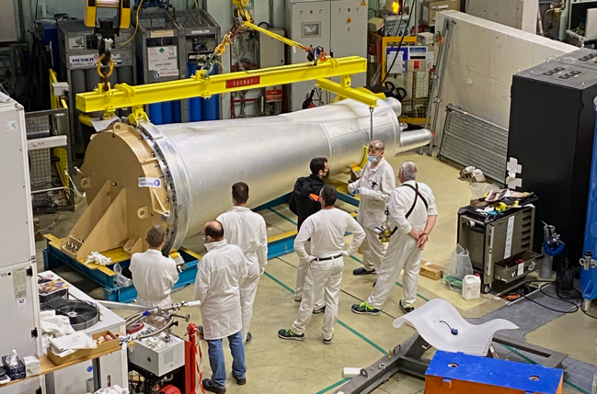
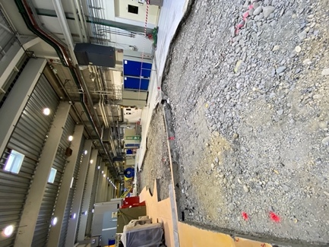
The most critical project during the past 16 months was the replacement of the H1-H2 beam tube and in-pile neutron guides that allow the extraction and transport of thermal- and cold-neutrons to instrumentation in the ILL7 guide hall (Figure 1). We have also taken the opportunity to modernise and renew infrastructure such as the H1-H2 swimming pool providing biological protection to the beam extraction, and the C5 third-barrier guide feeds through the outer reactor wall to ensure the highest safety standards and longevity of our key neutron delivery infrastructure.
Fig. 1. (top) Installation of the H1-H2 beam tube. (bottom) ‘Pink’-housing with the assembly of guide plateaus with the H1 (cold neutron) guides on the top and H2 (thermal neutron) guides on the bottom.

By the beginning of 2022 the ILL 7 guide hall had been excavated down to the river bed of the Grenoble valley (Figure 2). Reconstruction began promptly with extensive concrete landscaping ready to accept the new guide and instrument suites for both the H24 and H15 projects. Civil engineering work was phased beginning with the new D10+ zone and the H24 guide and working roughly in instrument order though the Chartreuse side of the guide hall. A similar situation was seen on the Vercors side of the guide hall with the dismounting of the old H1 casemate, H15 guide and instruments in preparation for civil engineering works. The staggered work plan for the H24 and H15 suites allowed for an optimisation of ILL staff, construction subcontractors and material resources.

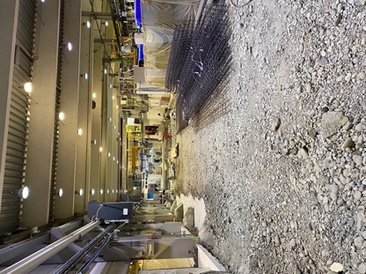
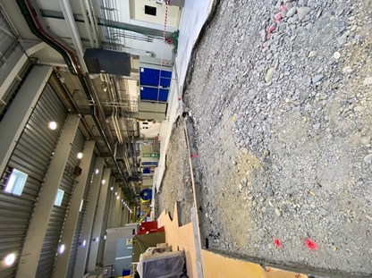
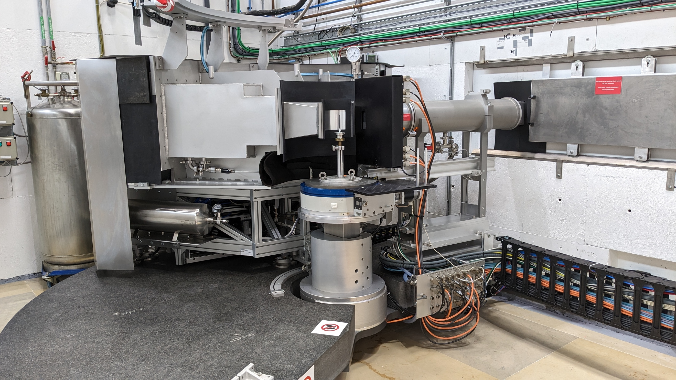
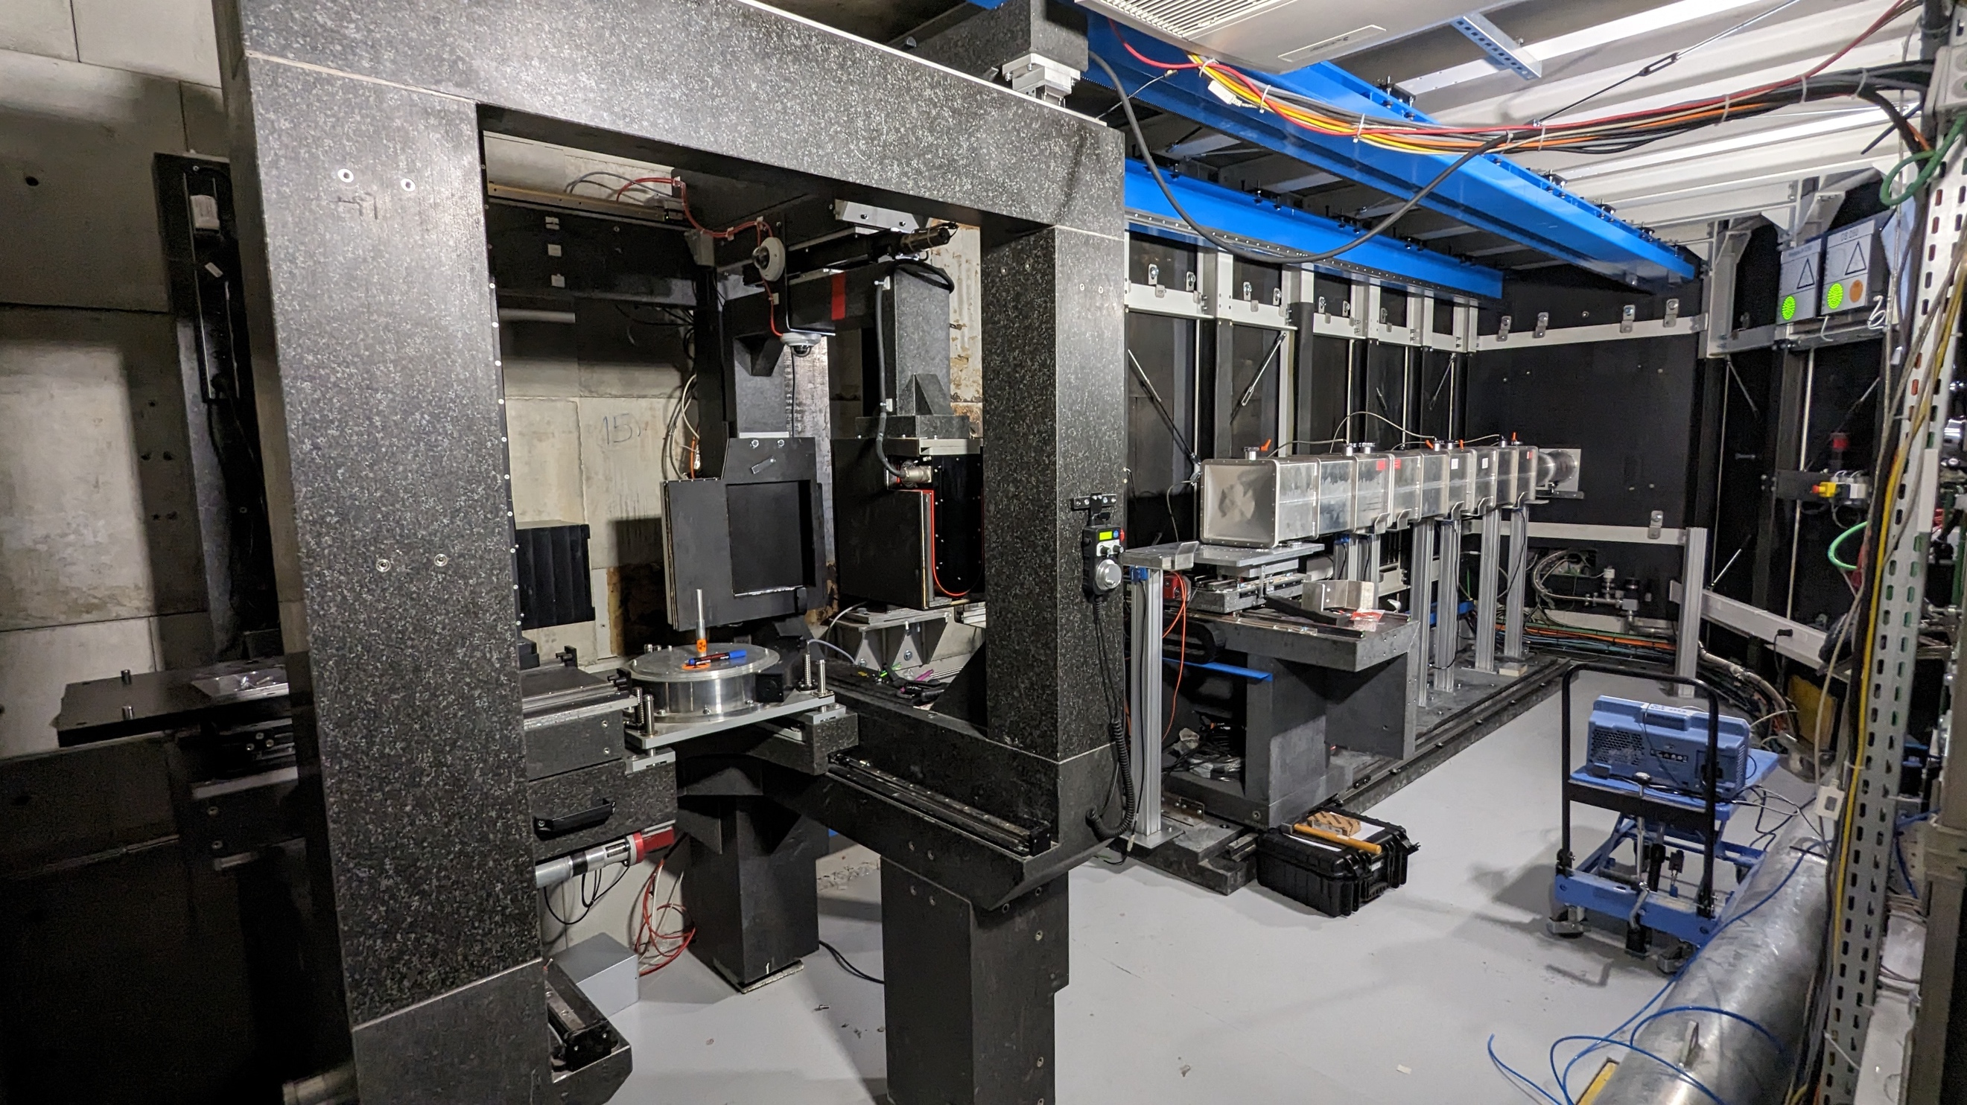
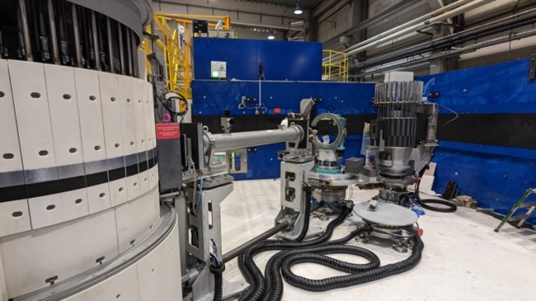
Fig. 2. The point of maximum destruction in the ILL 7 guide hall showing the excavation works for the new H24 (left) and H15 (right) guides and instrumentation suites.
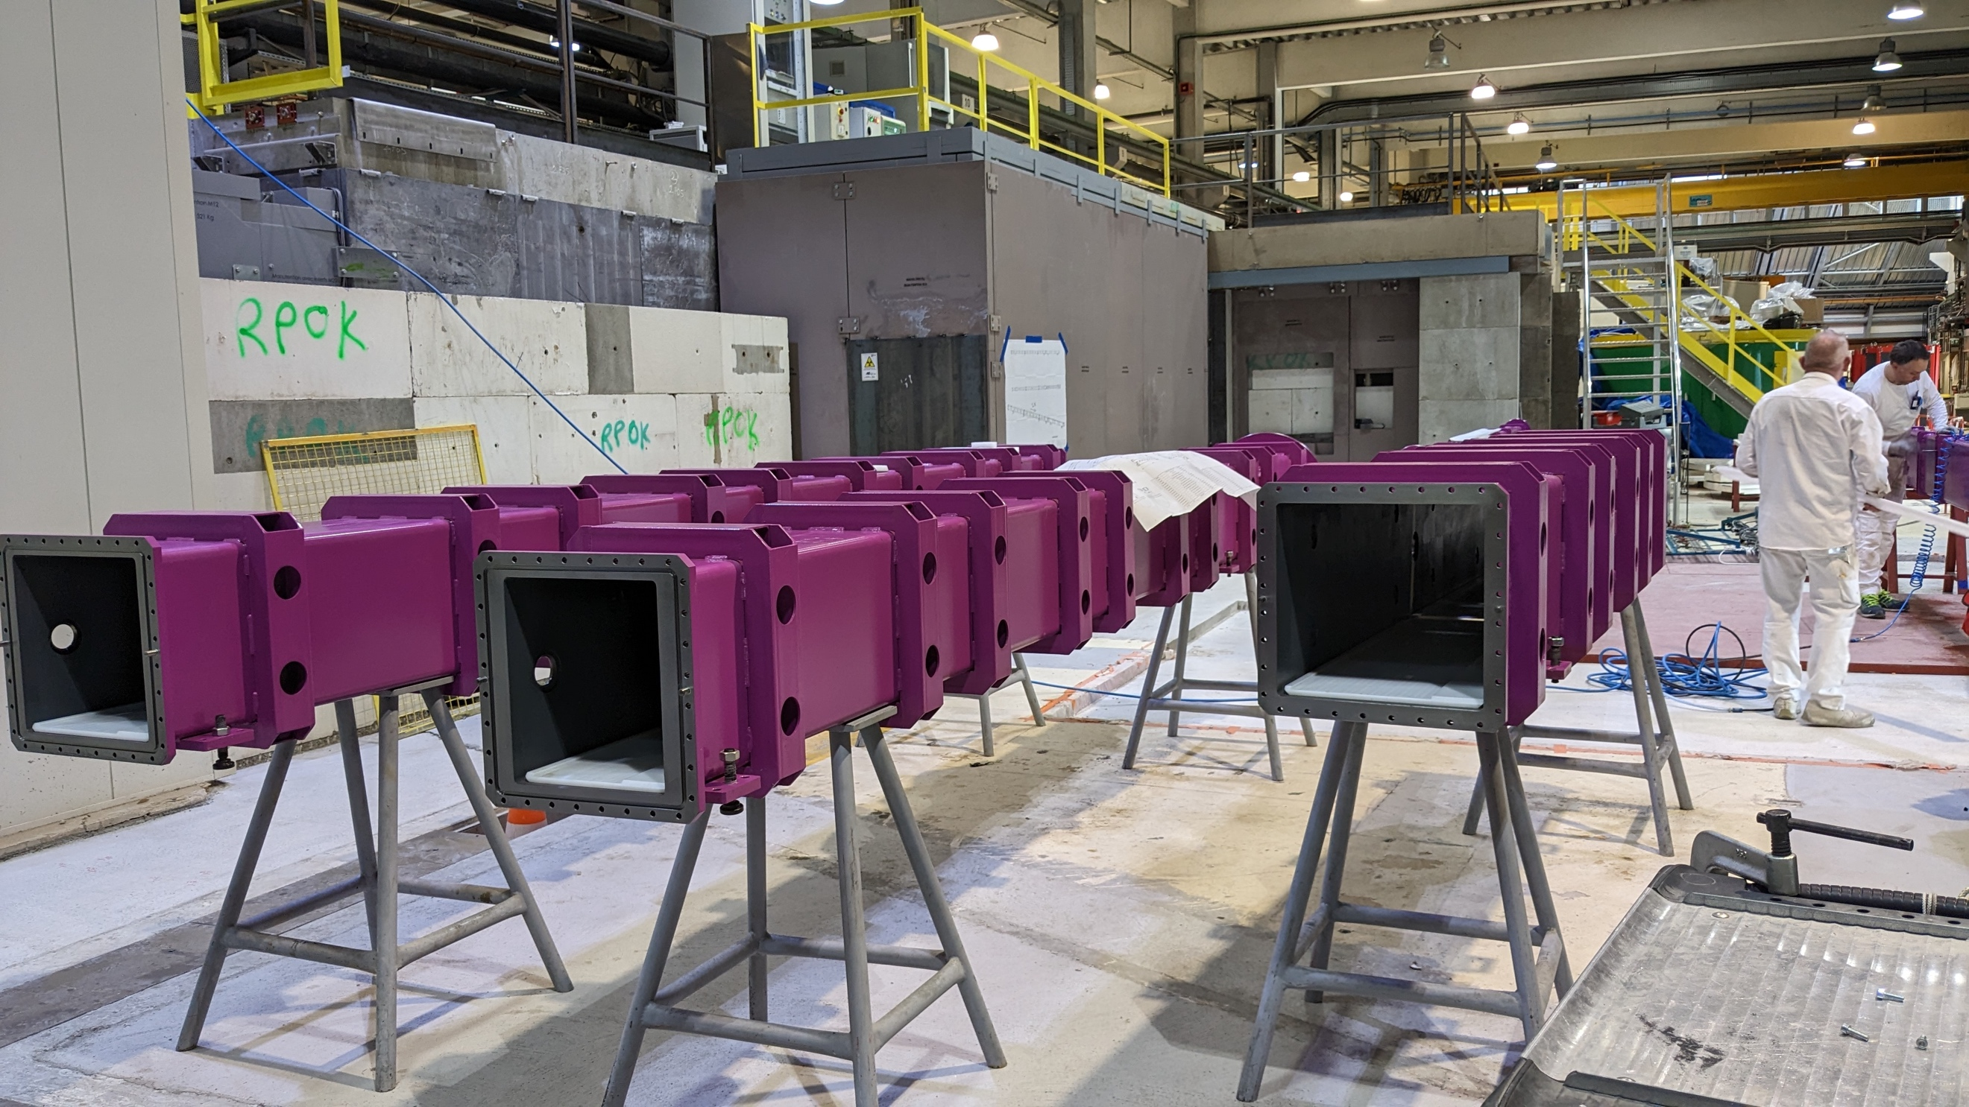
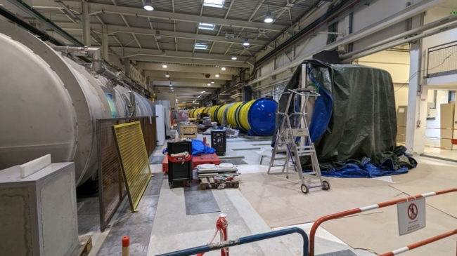
Fig. 3. (top) The D10+ thermal single crystal diffractometer installed on the new H24 guide. (middle) H15 works showing the D11 and SHARP+ flight chambers relocated into their new positions. (bottom) Guide housings for the new H15 guide under preparation in front of the new H1 casemat in ILL7.

Concrete landscaping on the H24 side was completed in the summer of 2022 and marble laid allowing installation of the first instrument components for D10+ and XtremeD. Civil engineering work on the H15 side was also well advanced with work on the new H1 steel casemate and foundation pillars for the relocated D11 detector tank. By the end of the summer, the last sections of H24 were installed up to the new FIPPS position along with the H24 steel shielding tunnel. The IN13 and CT2 instruments began re-installation while the new floors for FIPPS and SHARP+ were prepared at the ends of the H24 and H15 beamlines respectively.
The new H24 guide was completed by autumn 2022 while work on the instruments D10+, IN13, XtremeD and CT2 progressed (Figure 3 top). On the H15 side the D11 detector tube was moved into its new position and the SHARP+ flight chamber was delicately ‘air-lifted’ though the roof of ILL7 into its new position at the end of the guide hall (Figure 3 middle). Meanwhile, in the reactor building and following the successful replacement of the H1-H2 beam tube, ‘pink’-carter and plateau of in-pile neutron guides, connection of the new guide system to new swimming pool and H5 casemate guides progressed ready to meet up with the ILL7 guides.

Fig. 4. (top) New cold-neutron and x-ray imaging instrument NeXT. (bottom) New secondary spectrometer of the D16 cold-neutron diffractometer with in-house manufactured trench multi-wire proportional counter (TMWPC) detector.

We have completed all ‘skeleton’ tasks and much more during the H1-H2 shutdown concerning both the instrument suite under Endurance and reactor maintenance. The H1-H2 shutdown and Endurance has delivered a fully modernised H24 guide and instrument suite (D10+, IN13, XtremeD and CT2) as well as a number of independent instrument projects such as NeXT (Figure 4 top). The cold neutron diffractometer and wide-angle scattering instrument D16 has received a fully renewed secondary spectrometer including a new position sensitive detector covering four times the solid angle of the previous detector allowing for more rapid measurements over an extended q-range (Figure 4 bottom, Figure 6). Although already commissioned in 2020, the thermal TOF spectrometer PANTHER further increases its performance thanks to its new cascade of five background choppers. SuperSUN has finally produced its first ultra-cold neutrons after an extended and complex instrument project and commissioning. The renewed suite of H15 instruments (D007, D11, T3, Sharp+ and Sam) is on schedule for delivery and commissioning during 2024.
  - H24 guide and instruments D10+, IN13, XtremeD, CT2, FIPPS
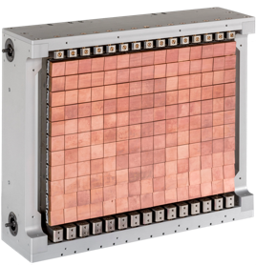
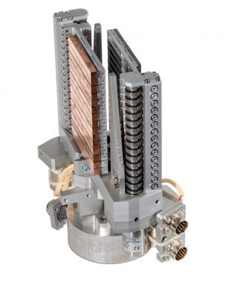
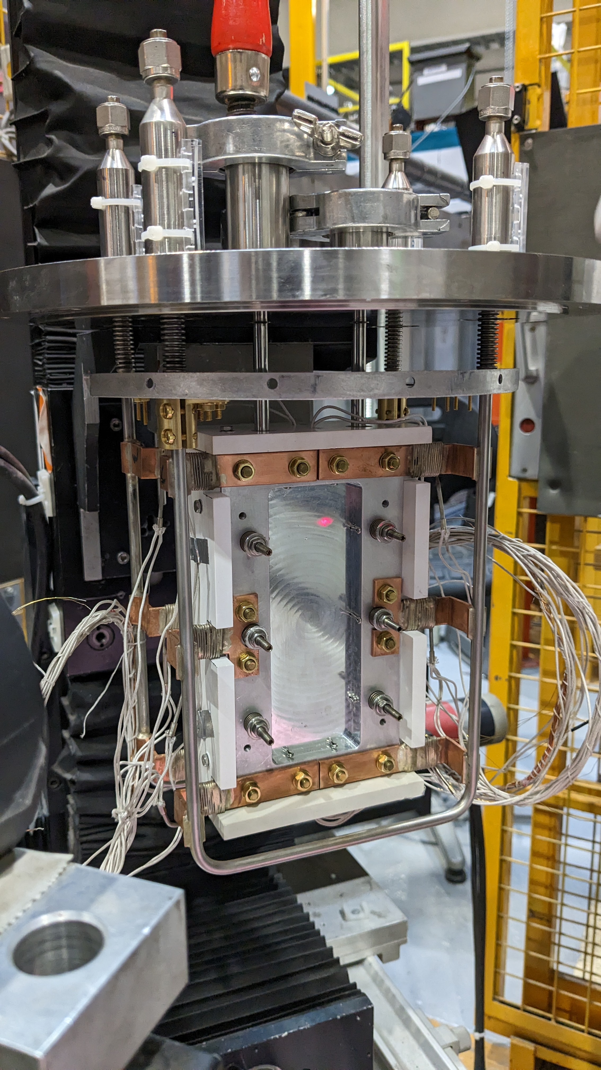
The new H24 guide brings dedicated thermal neutron guides to upgraded D10+, IN13 and the new XtremeD (CRG) powder and single-crystal diffractometer as well as providing neutrons to the test instrument CT2 and a repositioned FIPPS. Each instrument benefits from a dedicated end-of-guide position allowing for optimised beam-shaping and monochromator optics. The new guide has a high critical angle coating (m=3) and exploits the two radii of curvature of the H241 (R=14000m) and H242 (R=8000m) down-stream sub-branches to naturally curve and expand the guide over a distance of 22 m. Gold-foil activation give a neutron flux of 2.5 x 10⁹ n / s / cm² at the position of the D10+ instrument compared with a value of 0.7 x 10⁹ n / s / cm² for the old guide system measured at a similar distance from the source just before the renovation. We have measured a total gain in count rate of 11 times on the new D10+ single crystal diffractometer (Cu monochromator at 1.26Å) with respect to the old D10 instrument due to the efficiency of the new detector (x1.6) and neutron flux (x6.6) due to the increased divergence, guide and monochromator size. Similar gains in intensity have been measured on IN13, primarily due to the performance of the new H24 guide coupled with a new temperature-gradient monochromator which is in the process of being optimised (Figure 5 right). New capabilities and capacity is available with the new CRG powder and single crystal diffractometer XtremeD having a performance to rival that of D20c. The renewed CT2 instrument for the testing of detectors also forms part of the H24 instrument suite while the end of the new H24 guide will make way for the future relocation of the fission fragment spectrometer FIPPS giving the instrument space, reduced background and most importantly a stable and intense neutron beam.
  - H15 guide and instruments T3, D007, D11, SAM, SHARP+
The H15 guide has a rather complex opposing-curved expanding section, referred to as ‘the trumpet’. The trumpet serves two important purposes: The first is to spatially expand the neutron guide, thus converting the up-stream high divergence to a lower divergence but extended over a greater area. This allows the guide to be split into multiple individual guide branches allowing five dedicated end-of-guide beam positions for instrumentation. The second is that the opposing curve leaves a ‘fingerprint’ correlation between the divergence profile and spatial position at the end of the trumpet. In other words, neutrons on the left of the guide have a divergence distribution on average pointing to the left and conversely for the right side of the guide. Importantly, this allows guide branches to be more widely separated in angle, therefore allowing space for substantially more instrumentation downstream.
Civil engineering works for H15 are now complete allowing the cold-neutron instruments on the Vercors side of ILL7, excluding the H15 instruments, to restart with the ILL reactor. The H15 works have been scheduled intentionally so as to allow continued construction of the out-of-casemat H15 guide and instruments during reactor operation in 2023. The next long shutdown at the end 2023 will allow the final in-casemat installation of the new H15 guides, finally connecting the new guide to its new instrumentation suite ready for commissioning and user operation during the second half of 2024. We expect significant gains in performance from instruments such as D(00)7 and SHARP+ (CRG) compared to their predecessors D7 and IN6 due to the new high performance H15 guide, dedicated focussing guide and beam optics and improved or larger detectors. In the case of D(00)7 the expected order of magnitude increase in flux will make polarisation and spectroscopic analysis measurements realistic as well as massive gains for the more usual diffuse scattering measurements. On the cold TOF spectrometer SHARP+ we expect more than ten times the count rate of its predecessor IN6. D11 will be rebuilt and relocated with an optically cleaner collimation and should re-gain its theoretical brilliance to match that of D22 and D33 as should that of the new CRG SANS instrument SAM which includes a MIEZE option. The test instrument T3, essential for the testing of polarised supermirrors produced in-house, will be rebuilt and upgraded and completes the H15 instrument suite offering increased flux and beam polarisation.
Fig. 5. (top-left) Double-focussing copper monochromator for PANTHER. (bottom-left) Single-focussing back-to-back copper and graphite (HOPG) monochromators for D10+. (right) Final alignment of the new temperature gradient monochromator for IN13 on T13c with the first neutrons of 2023.
  - In-house technologies
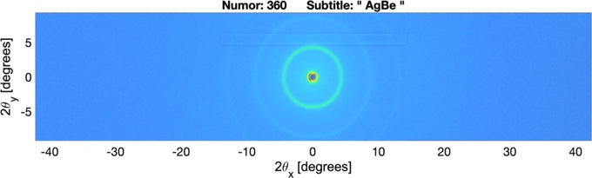
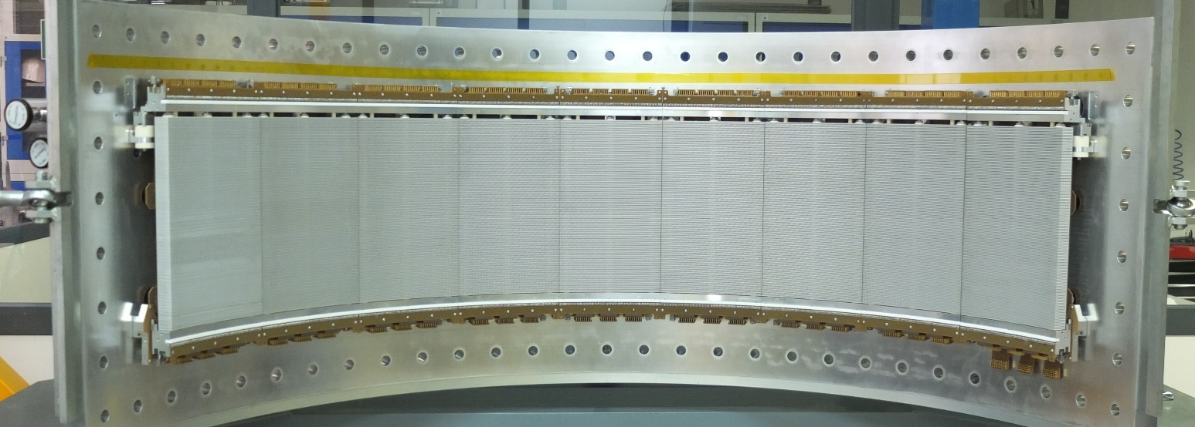
In-house developed technologies have been key to successful and efficient instrument upgrades [8,11,12,13,14]. Both single- and double-focussing monochromators have been produced for various instruments, some of which are show in Figure 5. The detector technology used for XtremeD (Figure 6) is an excellent example of the high-quality research, development and manufacturing carried out in-house by ILL’s services. The so-called Trench Multi-Wire Proportional Counter (TMWPC) [8] is a novel concept in detector technology allowing high count-rate and spatial resolutions down to 1.5 mm using ³He detection gas. This same technology is being used to provide detectors for D16 (Figure 4 bottom, Figure 6) and D20c.

Fig. 6. (top) ILL designed and manufactured Trench Multi-Wire Proportional Counter (TMWPC) detector technology for XtremeD, D16 and D20 [9]. D16’s new ‘banana’ detector has a radius of 1.15 m and 1152 x 192 pixels of resolution 1.5 mm and 2 mm [x,y]. (middle) Small-angle scattering from silver behenate. (bottom) Wide-angle diffraction from Yttrium-Iron-Garnet powder.
- Endurance projects
Endurance encompass more than 30 new or upgraded instrument and infrastructure projects. We have already delivered many new or upgraded instruments and infrastructure packages that are already in user operation.
  - Completed projects
• FIPPS: Fission fragment gamma ray spectrometer giving new capabilities in the identification of prompt short-lived fission products and entirely complimentary to the existing Lohengrin mass spectrometer [3]. (2016)

• RAINBOWS: A re-scoped project to upgrade the D17 reflectometer with a new focussing guide and chopper system [15] to pursue an alternative high-flux mode of operation using the so-called ‘coherent summing’ method [16]. (2018)

• IN5 / H16: Cold-neutron TOF spectrometer. The new elliptically focussing H16 guide boasts huge gains in intensity, in particular at shorter wavelengths while focussing onto much smaller samples [4]. Access to shorter wavelengths on IN5 improves the overlap with the new thermal-neutron TOF spectrometer PANTHER. (2019)

• NESSE 1 & 2: Stimulus in sample environment capabilities covering all scientific domains such as low- and high-temperatures, high pressure, magnetic fields, humidity environments, and equipment for soft-matter and biological sciences. (2019, 2023)

• BASTILLE 1 & 2: Stimulus in scientific computing - Modern data reduction and analysis software tools via the Mantid project. Mantid is now well developed and fully deployed over our suite of TOF spectrometers and begins adoption on our powder diffraction, reflectometry and SANS instruments (solution scattering). (2019, 2023)

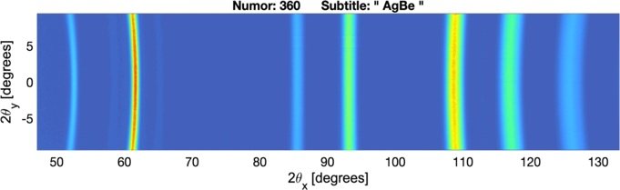
• PANTHER: New thermal-neutron TOF spectrometer replacing IN4 and with performance (signal / noise) approximately 60 times that if its predecessor. (2020). A cascade of 5 background choppers have been installed during the H1-H2 shutdown to further improve the performance of PANTHER. (2022)

• IN20: Upgraded thermal triple-axis spectrometer. A velocity selector for wavelength filtering and allowing much greater flexibility in instrument use and accessible energies. (2020). New graphite monochromator and analyser and a new Heussler monochromator [11]. (2023)

• Orient Express: Strategic move of instrument to H23 to allow uninterrupted access for sample alignment during the H24 works and to free up end-of-guide position for future relocation of FIPPS. (2020)

• DALI: Second protein crystallography instrument. Doubles the capacity and throughput of protein crystallography measurements with an increased neutron flux and flexibility due to the use of a velocity selector. (2020)

• D3 Liquids: The hot-neutron diffractometer is back in user operation following its beam tube replacement and upgrade with a new position-sensitive area detector and polarisation components, allowing for efficient measurement of hydrogen-containing liquid samples with precise discrimination of incoherent scattering [5]. (2021)

• D11 Detector: Replaced the aging multidetector with a modern, increased area, efficiency and count-rate detector. (2021)

• D22 Detector: An additional high-angle detector, massively extending the instrument’s dynamic q-range and making for more rapid measurements with a reduced number of instrument configurations. (2021)

• D16: New secondary spectrometer, including a new wide-angle detector bank [8] with approximately four times the angular coverage (85 degrees) of the previous detector. (2023)

• NeXT: A full re-build of the neutron imaging instrument allowing for state-of-the-art imaging with advanced contrast techniques, high spatial resolution, intense neutron flux and combined X-ray imaging [9]. A second (monochromatic) imaging station, MOTO, for measurements such as Bragg-edge and dark-field imaging as well as technique development is under installation. (2023)

• H24 guide: New thermal-neutron guide providing dedicated end-of-guide positions to D10+, IN13, the new powder and single-crystal diffractometer XtremeD (CRG) as well as providing neutrons to the test instrument CT2 and a relocated FIPPS. (2023)

• D10+: Renewed thermal single-crystal diffractometer with count-rates more than ten times that of the previous D10 instrument due to the new H24 guide, new and larger focussing monochromators and improved efficiency detector. (2023)

• IN13: New primary spectrometer, including new temperature gradient monochromator, optimised for the dedicated end-of-guide position on the new H24 guide [7]. (2023)

• XtremeD: New CRG thermal neutron powder and single crystal diffractometer with performance to rival that of D20. (2023)

• CT2: Renewed test instrument for the characterisation of neutron detectors. (2023)

• SuperSUN: The new ultra-cold neutron (UCN) source SuperSUN is in the commissioning phase with the successful fabrication and installation of the converter guide and cool-down of the superfluid He converter volume. This long and complex project has presented a great number of technical and operational challenges along the way but SuperSUN has begun to produce high densities of UCNs and will allow science to begin on the PanEDM experiment [6]. (2023)
  - Ongoing projects
A number of Endurance projects remain in execution such as the H15 guide and associated instrument suite. We have also been able to re-launch several new instrument upgrade projects in a last wave of the independent Endurance projects. Ongoing Endurance projects are:

• H15 guide: New cold-neutron guide providing dedicated end-of-guide positions to T3, D(00)7, D11, new SANS instrument SAM (CRG) and upgraded SHARP+ (CRG) cold TOF spectrometer. (2024)

• T3: Renewed reflectometry test instrument for the characterisation of supermirrors. (2024)

• D(00)7: Upgraded diffuse scattering diffractometer and spectrometer. The expected increased flux will make polarisation and analysis spectroscopic studies realistic [10]. (2024)

• D11: SANS instrument relocated onto the new H15 guide and upgraded with reliable and optically clean beam collimation. (2024)

• SAM: New SANS CRG instrument with MIEZE option. (2024)

• SHARP+: Relocation of the SHARP instrument (previously IN6) onto the new H15 guide and upgrade of the primary spectrometer with focussing guide, monochromator and chopper cascade. (2024)

• D20c Detector: Replace the existing aging microstrip detector [17] with a new banana detector of TMWPC technology [8] (Figure 6). (2024)

• MARMOT: Multiplexed energy and angle analysis on the cold-neutron TAS instrument Thales. Detector elements and bent silicon analyser crystals for the spectrometer will use in-house technologies and fabrication. (2024 / 2025)

• WASP: The wide-angle spin-echo instrument [18] will receive its full complement of detectors with completion of the first additional detector bank due in 2024. (2024 / 2025)
- Post-Endurance instrument upgrades and opportunities
We intend to continue upgrading our instrumentation after the completion of Endurance 2 wherever we can achieve the highest impact and cost-efficient upgrades that are independent of large infrastructure. We will capitalise on the high-quality and unique expertise of our in-house technical services in the provision of neutron technologies such as detectors, optical components, electronics, computing and sample environment.
In order to strengthen our research capabilities with high societal impact, e.g. materials research, process development, and health, potential smaller upgrade projects that are already identified include:
• Move FIPPS to a H24 end position to provide more intense and cleaner beam, more space for experimentation, and to allow an upgrade of SALSA (autumn 2023).
• Additional (Cu 200) monochromator for SALSA providing increased flux (up to x5) and instrument capabilities at longer wavelength (e.g. access to titanium-based materials and carbides).
• Additional thermal neutron imaging station providing additional capabilities and capacity.
• Velocity selector upgrade to LADI allowing increased flexibility in choice of wavelength and increasing the flux by up three times compared to the current wavelength filter.
• Camera-based detector system for LADI and DALI allowing quicker and continuous readout and higher detection efficiency.
• Use of machine learning and AI techniques for optimised instrument control, data acquisition and analysis.
• Continuous development of sample environments (e.g. for levitation techniques and in-operando additive manufacturing set-ups).
• Improved shielding and background reduction – overall improvement of signal-to-noise on instruments.
• New choppers, velocity selectors, monochromators, analysers, detectors.
The ILL scientific community will be consulted for upgrade proposals in due course and when we have greater visibility of the financial landscape for post-Endurance upgrades.

Summary
The present article gives an overview of the modernisation of the instrument suite and critical infrastructure at the Institut Laue-Langevin. The Endurance programme (2016 – 2023) has seen the upgrade, modernisation or complete renewal of more than 30 instrument and infrastructure projects, many of which have now been delivered and are available to users in the science programme. The remaining ongoing Endurance projects, in particular the H15 neutron guide and associated suite of instruments, will be completed and enter the user programme in 2024. We intend to continue to upgrade our instrument suite after the completion of Endurance and have identified a number of high-impact projects. The Millennium and Endurance programmes over the last 20 years have ensured ILL has a fully modernised suite of world-class instruments ready to operate for the decade to come.

We would like to acknowledge and thank all ILL staff for their outstanding contributions in the execution of the Endurance projects and the massive undertaking of works during the H1-H2 shutdown. The goodwill, mobility and competence of our staff has ensured these vast works remained on schedule. In particular we would like to mention the project managers and instrument teams involved in all Endurance, infrastructure and reactor projects over recent years. Endurance could not have succeeded without the broad technical oversight of Benjamin Giroud in the implantation of the H24 and H15 neutron guide projects and their associated suites of instruments. Our fully modernised instrument suite would not be possible without the expertise of the ILL technical services for detectors, optics, electronics and instrument control, design, engineering and mechanics, and construction.

References
- https://www.ill.eu/users/instruments/modernisation-programmes/millennium-programme
- https://www.ill.eu/users/instruments/modernisation-programmes/endurance
- C. Michelagnoli, A. Blanc, E. Ruez-Martinez, A. Chebboubi, H. Faust, E. Froidefond, G. Kessedjian, M. Jentschel, U. Köster, P. Mutti, G. Simpson, EPJ Web Conf. 193, 04009 (2018)
- J. Ollivier, B. Giroud, M. Kreuz, E. Farhi, J. Beaucour, C. Dewhurst, J. Neutron Res. 20, 123 (2019)
- A. Stunault, S. Vial, D. Jullien, G. Cuello, Physica B 551, 373 (2018)
- E. Chanel, S. Baudoin, MH Baurand, N. Belkhier, E. Bourgeat-Lami, S. Degenkolb, M. van der Grinten, M. Jentschel, V. Joyet, M. Kreuz, E. Lelièvre-Berna, J. Lucas, X. Tonon, O. Zimmer, J. Neutron Res. 24, 111 (2022)
- A. J. C. Dennison, F. Natali, E. Farhi, G. Manzin, P. Courtois, J. Peters, Nucl. Instrum. Methods Phys. Res. A 908, 182 (2018)
- J. C. Buffet, J. F. Clergeau, S. Cuccaro, B. Guerard, N. Mandaroux, J. Marchal, J. Pantenero, M. Platz, P. Van Esch, JINST 12, C12009 (2017)
- A. Tengattini, N. Lenoir, E. Ando, B. Giroud, D. Atkins, J. Beaucour, G. Viggiani, Nucl. Instrum. Methods Phys. Res. A 968, 163939 (2020)
- G. J. Nilsen, K. L. Brown, L. Mangin-Thro, W. Clancey, B. Giroud, C. D. Dewhurst, A. R. Wildes, Nucl. Instrum. Methods Phys. Res. A 951, 162990 (2020)
- P. Courtois, B. Hamelin, K. H. Andersen, Nucl. Instrum. Methods Phys. Res. A 529, 158 (2004)
- P. Courtois, J. Phys.: Conf. Ser. 746 012005 (2016)
- P. Courtois, T. Bigault, K. H. Andersen, J. Baudin-Cavallo, K. Ben Saidane, M. Berneron, A. El-Aazzouzzi, D. Gorny, W. Graff, T. Guiblain, R. Hehn, E. Hetzler, C. Menthonnex, B. Mestrallet, C. Dewhurst, Physica B 385, 1271 (2006)
- T. Bigault, G. Delphin, A. Vittoz, V. Gaignon, P. Courtois, J. Phys.: Conf. Ser. 528 012017 (2014).
- T. Saerbeck, R. Cubitt, A. Wildes, G. Manzin, K. H. Andersen, P. Gutfreund, J. Appl. Cryst. 51, 249 (2018)
- R. Cubitt, T. Saerbeck, R. A. Campbell, R. Barker, P. Gutfreund, J. Appl. Cryst. 48, 2006 (2015)
- J. F. Clergeau, P. Convert, D. Feltin, H. E. Fischer, B. Guerard, T. Hansen, G. Manzin, A. Oed, P. Palleau, Nucl. Instrum. Methods Phys. Res. A 471, 60 (2001)
- R. Holzel, P. M. Bentley, P. Fouquet, Rev. Sci. Inst. 77, 105107 (2006)

Fig. 7. Layout of the ILL instrument suite over the ILL 5 reactor building and the ILL 7 and ILL 22 guide halls. Instruments completed or in-progress as part of the Endurance programme are highlighted according to the legend while neutron guides are also indicated.

