Modelling of The New Engineering Diffractometer eMAP at ISIS Target Station 2
Tung Lik Lee¹, Saurabh Kabra¹, Joe Kelleher¹, Winfried Kockelmann¹ and Robert Bewley¹
¹ISIS Neutron and Muon Source, Science and Technology Facilities Council, Rutherford Appleton Laboratory, Didcot, OX11 0QX, UK
Abstract. eMAP is a new proposed high flux medium-resolution time-of-flight engineering diffractometer that will be built at ISIS Target Station 2. Monte Carlo simulations were performed to optimise the neutron guide to maximise brilliance transfer. eMAP features great flexibility in tuning for flux or resolution. The diffractometer achieves a figure of merit that surpasses the ENGIN-X diffractometer at ISIS by more than a factor 10. The new instrument will bring additional capacity and advanced stress measurement capabilities to the engineering diffraction user programme at the ISIS Neutron and Muon Source.

- Introduction
The ISIS Neutron and Muon Source is now seeking its next phase of new instruments and significant upgrades to existing instruments: a portfolio of projects that is called the Endeavour Programme [1]. Endeavour will increase both capacity and capability of the facility to address 21st century challenges and enable research in areas such as advanced materials and manufacturing, clean energy technologies, and biosciences and healthcare. Starting in the 2023/24 financial year, the Endeavour Programme will construct four new instruments and five significant upgrades to existing instruments, over a 10-year period.

ENGIN-X [2] is currently the only instrument at ISIS dedicated to neutron diffraction strain scanning of engineering components. Strain scanning at more modest resolution will also be available on IMAT [3] once the current project to install 2θ=±90° detectors and collimators is completed, though beamtime will be shared with the imaging programme on the instrument. A majority of the experiments conducted on ENGIN-X have industrial collaboration. However, ENGIN-X, which serves as the primary instrument, is over-subscribed, particularly for industrial access. To address the growing demand from industry, a new engineering instrument is necessary to provide additional capacity and new capabilities for stress measurement in the interior of full-size engineering components and characterisation of dynamic material behaviours at extreme conditions, allowing industrial manufacturers and materials engineers to design components that are more advanced and machines with enhanced performance, durability, and capabilities.

Here we report on the modelling of the new proposed time-of-flight engineering diffractometer, eMAP, which will be built at ISIS Target Station 2 (TS2). TS2 is a pulsed source operating at 10 Hz. The name of the instrument refers to strain mapping, with the letter ‘e’ representing the Greek letter ‘ε’ (strain). eMAP is designed with a performance complementary to the diffraction capabilities offered by ENGIN-X and IMAT. The high diffraction resolution of ENGIN-X is likely to be difficult to match. Therefore, eMAP is optimised as a medium resolution instrument offering higher flux and figure of merit than ENGIN-X. eMAP offers tuneable functionality to measure residual stress in large, heavy, thick, and intricately shaped components, offer improved 2D/3D strain mapping, and enable the study of short-timescale phenomena (e.g. in-situ welding) under extreme sample conditions relevant to industrial processes. The performance of eMAP will result in improved data acquisition times and greater depth penetration capability compared to ENGIN-X, representing a significant advancement in our ability to study real engineering components at ISIS.
- Modelling of the instrument
  - Instrument layout
Fig. 1 shows the basic layout of eMAP. The instrument will be viewing the 120×120 mm² 40 K decoupled poisoned methane moderator at TS2. The primary flight path (L₁) is 40 m. eMAP features an elliptic guide to help maximise incident vertical divergence. Due to the low horizontal divergence required for strain scanning, the sides of the guide are straight. The guide has a cross-section of 40×60 mm² (width × height) at the entrance of the guide at L₁=1.7 m from the moderator face. The height of the guide expands to a maximum of 149 mm at mid-length of the instrument. The cross-section at the end of the guide is 40×56.5 mm². The guide ends at 1.5 m (L₁=38.5 m) from the sample position to ensure ample sample area to accommodate various sample environment and specimen sizes. The coating at the top and bottom of the guide has non-uniform distribution that features m=3 at mid-length and increasing m-value of up to m=5 at both ends of the guide to maximise brilliance transfer efficiently. The sides of the guide have m=1.5 coating due to the low horizontal divergence requirement for strain scanning. The guide is designed with a removable section upstream as a contingency measure so that a T0 chopper could be retrofitted, if necessary. Two single disk choppers operating at the source frequency of 10 Hz are positioned at L₁=8 m and 10 m to define the wavelength band, prevent frame-overlap of neutrons between successive neutron pulses and neutron leaking through the disk choppers at long wavelengths. The chopper positions have been optimised using path-time and phase space simulations to ensure no frame overlap and no neutron leaks at long wavelengths of up to 200 Å. The wavelength bandwidth of the instrument is ~9 Å.
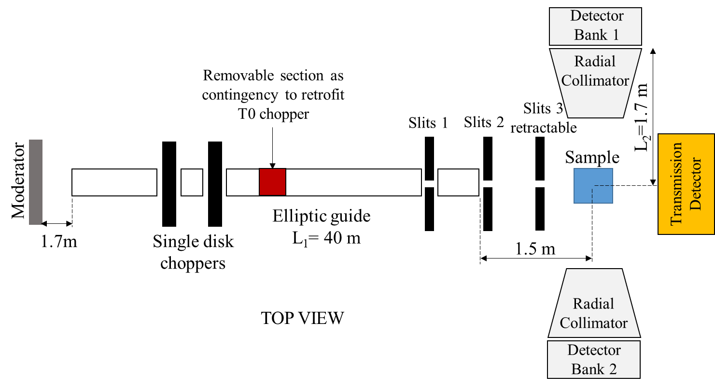
Fig. 1. Schematic of eMAP showing the main components of the instrument.
It is envisaged that the samples studied on eMAP will have different levels of sample-induced broadening which can lead to varying counting time requirements. Therefore, this calls for an instrument with a variable divergence which can be adjusted to match the peak broadening introduced by the sample since typically the incident flux can be increased if one is willing to increase the divergence. A total of three sets of slits will be positioned downstream the guide to control divergence. In order to minimise the number of gaps required in the guide system, only the first set of slits is positioned in the guide. The second set will be installed immediately after the guide exit. The final set of slits will be retractable between the second set of slits and sample, and defines the beam size at sample position.

Wavelength shifting fibre coupled ZnS:Ag/⁶LiF detectors will be installed on eMAP. Two diffraction detector banks at 2θ=±90° will enable the measurement of two orthogonal strain components simultaneously to minimise data acquisition times. The detectors will be positioned at 1.7 m from the sample position and will be mounted with removable radial collimators to define the size of the gauge volume (GV) along the beam. A total of five sets of radial collimators providing 0.5, 1, 2, 3, and 4 mm gauge width options will be made available. The instrument will provide a large sample area to accommodate unique sample environments and large engineering components. For example, the available space between the radial collimator faces for a 2 mm gauge collimator is estimated to be about 1 m similar to the specifications at IMAT [4]. As a comparison, the same collimator gauge size on ENGIN-X provides a gap of about 0.6 m between the collimator faces [2].

To match the incident beam divergence and meet the requirements for texture measurement, a detector pixel size of 3×100 mm² (width × height) was chosen. With 100 mm high pixels at 2θ=90°, eMAP will achieve an angular resolution of about 3.4° which helps with recording of sharp textures. A large detector coverage is required to ensure a high count rate and facilitate texture measurement. However, the error introduced into strain measurements through averaging over a range of detector angles increases with the angular span. At eMAP, the detectors will have angular coverage of ±14° horizontal and ±21° vertical similar to that of ENGIN-X which is well optimised for strain measurements. Previous studies have shown that detector arrays of up to ~±20° (horizontally and vertically) give errors that are small compared to the uncertainty in strain from a typical engineering instrument [5]. It is worth noting that elastic strains in engineering materials are typically of the order of 10⁻³ to 10⁻⁴, requiring strain measurement uncertainties (strain resolution) of the order of 10⁻⁴ to 10⁻⁵. Such accuracy in Bragg peak shift determination can be achieved by good Bragg peak definition and thus instruments of different diffraction resolutions and count rates achieve the same strain resolution by counting for different times. For example, to achieve the same strain resolution of 50 microstrain, ENGIN [6] had to count >10 times longer than ENGIN-X. Therefore, the overriding requirement of an engineering diffractometer is to obtain peak positions with a given uncertainty for a minimum counting time period. Thus, a figure of merit (FOM) is defined as:
FOM = I / ω² ₍₁₎
where I is the Bragg peak intensity and ω is the peak width to describe the performance of an engineering instrument [7].

Additionally, a transmission detector will be made available to enable for Bragg edge mapping.
  - Instrument location at TS2
Fig. 2 shows the three potential locations for constructing eMAP at TS2. Position 1 features an L₁ of 64 m, which is the longest possible length for an instrument facing this viewport. However, building a new external structure to accommodate the instrument at this position would incur an additional cost of about £5 million. Positions 2 and 3 have shorter L₁ of 40 m and are located within the R80 building. After careful consideration, position 3 that views the W2 (‘West’ 2) beam port on TS2 was selected as the location to build eMAP due to its advantage of providing height space to include an overhead crane, while requiring fewer building and floor alterations compared to position 2.
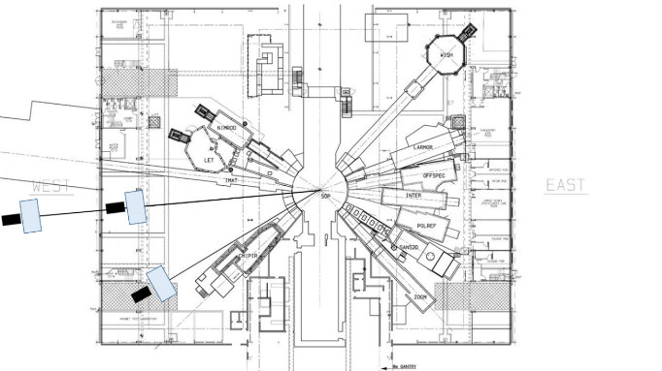
1
2
3
Fig. 2. Potential locations of eMAP at ISIS Target Station 2.
  - Modelling approach
The Monte Carlo modelling package McStas 2.5 [8] was used to model and optimise the instrument parameters. The decoupled poisoned methane moderator viewed by eMAP was modelled using the ‘Commodus_I’ [9] component and the methane moderator file (W4_Base_2022_wDecFL_wPOISeMapSide_off6mm_hExc12mm.mcstas) produced by the ISIS Neutronics Group. In the simulations, 2×10¹⁰ neutrons were generated in the wavelength bandwidth of 0.1-9.4 Å. Experimentally determined neutron guide coating reflectivity profiles provided by SwissNeutronics AG were used. The choppers were disabled in the simulations but the gaps in the guide at the chopper positions were retained. A beam size of 4×10 mm² (width × height) was defined at the sample position using the final set of slits set at 200 mm from the sample position. The TOF_spher detector component that describes a spherical detector arrangement with upper and lower limits in 2θ and φ, and which creates time-focused 1D spectra detected at 2θ=±90° was used in the model. The TOF_spher detector component is modified from the TOF_logspher component to include the contributions from the detector pixel size. The detector radial collimators were excluded from the simulations to reduce computation times. A 4×10×4 mm³ (width × height × depth) CeO₂ sample was used to emulate the dimensions of the GV defined at the sample position. The flux and Bragg peak profiles of existing ISIS instruments, namely WISH [10] (views the same methane moderator) and ENGIN-X, were simulated with the aforementioned assumptions. Comparison with experimentally measured profiles (Fig. 3) shows good agreement was found which gives confidence that the predictions from the simulations of eMAP presented herein are representative of the actual performance.
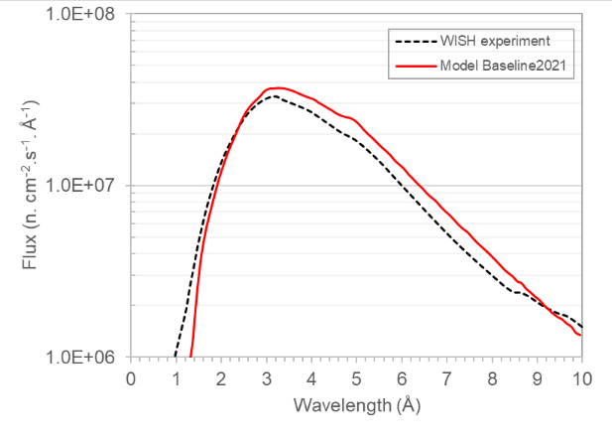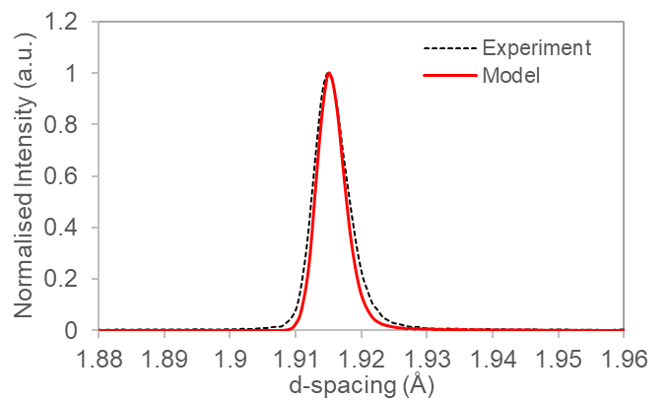
CeO₂ (220)
(a)
(b)
Fig. 3. (a) Neutron flux distribution of WISH at sample position, and (b) Bragg peak from ENGIN-X.
    - Guide geometry
An elliptic guide was selected for eMAP to maximise flux. The elliptic guide design was adjusted to feature a constant width along its length to due to the low horizontal divergence requirement for strain scanning. Simulations were performed to compare its performance with other guide geometries such as the straight guide of rectangular cross-section and ballistic guide (divergent at the start, straight in middle then converging at end). Fig. 4 shows the elliptic guide generally gives higher brilliance transfer (BT) at λ>0.8 Å and achieves >90% BT at λ=2-3 Å where most dominant Bragg peaks of engineering materials are located. The BT simulations were performed using a divergence of 0.12°×0.6° half width at half maximum (HWHM) at sample position. The small 0.12° horizontal divergence was selected to achieve good diffraction resolution and a homogeneous beam profile. It was found that a uniform beam can be defined at the sample position by controlling the vertical divergence up to ~0.4°. Nevertheless, the vertical divergence was increased to 0.6° in the BT simulations to account for the need of higher flux with certain experiments.
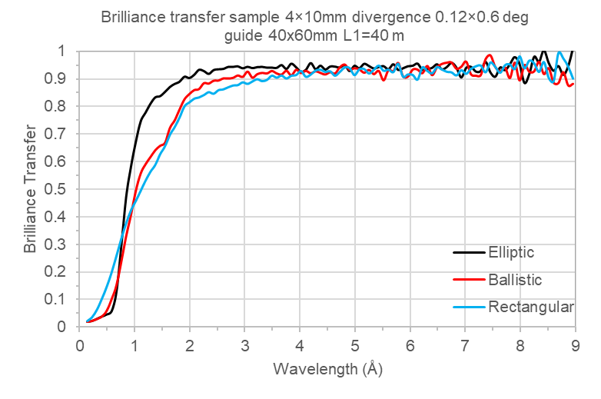
Fig. 4. Brilliance transfer of the straight m=3 guide in various geometries. 40×60 mm² guide cross-section defined at the entrance of the ballistic and elliptic guides. Ballistic guide is elliptic in the first and final 10 m of L₁.

The conventional design for engineering diffractometers often includes a curved section in the guide to eliminate line of sight. This is to reduce the exposure of the sample to significant levels of neutron and gamma radiation that could potentially compromise further processing or characterisation of engineering components or valuable specimens after neutron measurements. However, a straight guide combined with a T0 chopper could be considered as an alternative. Fig. 5 shows the BT from straight and curved elliptic guides (m=3 coating). The straight guide was designed with a 300 mm gap in the upstream section of the guide to fit a T0 chopper. The straight guide design proved to be more effective compared to a curved guide, particularly at λ<2 Å where the curved guide demonstrated poorer BT. As a result, a straight elliptic guide was chosen for eMAP. It is worth noting that experimental measurements showed that prompt pulse neutron and gamma fluxes are low on an existing instrument at TS2 that has similar straight elliptic guide with the same L₁ and views the methane moderator. Thus, fast neutron and gamma contributions to signal-to-noise at eMAP are expected to be low and the T0 chopper could be omitted from the straight guide. Nevertheless, a removable section of the guide is included in the guide design as a contingency measure so that the T0 chopper could be retrofitted, if necessary.
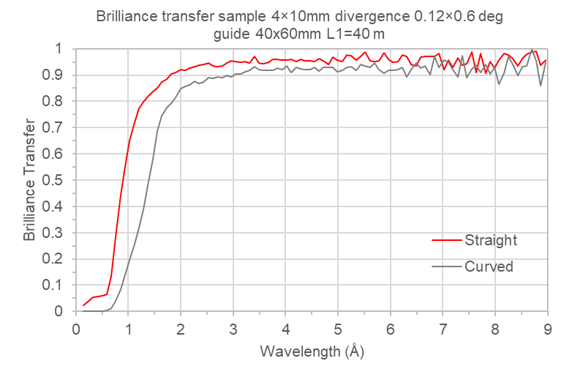
Fig. 5. Brilliance transfer of a straight versus curved m=3 elliptic guides.
    - Elliptic guide cross-section dimensions
Fig. 6 shows the BT of a straight elliptic guide with m=3 coating simulated with various guide cross-section dimensions. The guide height refers to the dimension at the entrance of the elliptic guide. In the downstream sections, the guide height varies according to the dimension defined at the entrance. A 40 mm wide guide achieves the maximum BT of ~95% at λ>2 Å. The 60 mm height at the guide entrance gives the maximum BT at λ>2 Å and high BT at low λ region. Heights larger than 60 mm generally gives similar or slightly lower BT at λ>1 Å. Therefore, the 40×60 mm² guide cross-section at the entrance of the elliptic guide was chosen for eMAP.
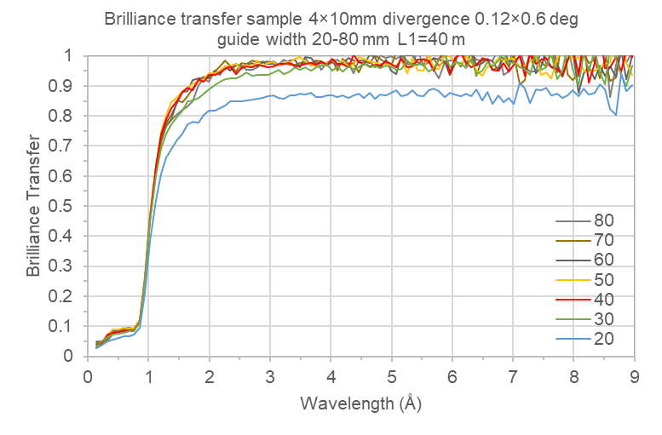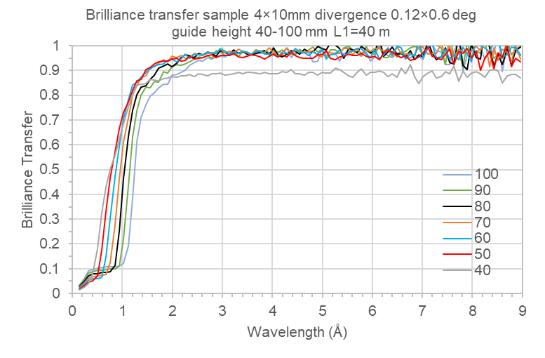
Fig. 6. Brilliance transfer of the straight m=3 elliptic guide simulated with various guide heights and widths. The guide height refers to the height defined at the entrance of the elliptic guide. In the downstream sections, the guide height varies according to the dimension defined at the entrance.
    - Guide coating
Fig. 7a shows the BT of the straight elliptic guide specified with various uniform guide coating up to m=5. Coatings higher than m=5 was not considered due to high costs. Based on the BT, a minimum of m=3 is recommended as it gives significant gains compared to m=2 at λ<3 Å and reasonable BT (~40%) at around 0.8 Å. This λ range (0.8-3 Å) is particularly important for engineering materials, for e.g. Fe. Although BT at short wavelengths generally improves with higher m-values, it is often more cost effective to apply non-uniform guide coating distribution with higher m-values at both ends of the elliptic guide. Fig. 7b and 7c show the various coating distributions considered for the elliptic guide. Fig. 7d shows that the non-uniform coating distribution is effective at increasing BT at λ<3 Å. Model A (up to m=5 at the ends and m=2 in the central region) showed higher BT of a few percent at around λ=2 Å when compared to a uniform m=2 guide coating. Nevertheless, the BT of Model A at λ=~0.8 Å is poor compared to a uniform m=3 coating. Therefore, the non-uniform coating distribution that features m=3 in the central region (Model B) was selected for eMAP. Further optimisation of the coating distribution will be performed to further improve BT.

A low m-value coating of m=1.5 was chosen for the sides of the guide due to the small horizontal divergence. This arrangement gives a slight decrease of ~3% in BT that is mostly limited to λ=1-2 Å region compared to m=3 coating but delivers significant cost savings.
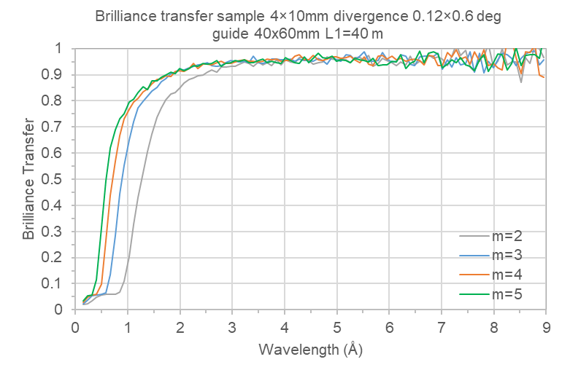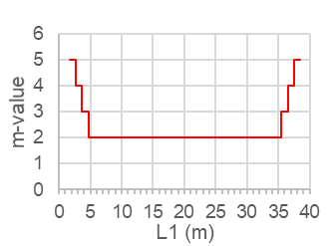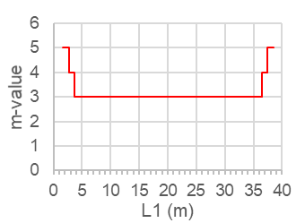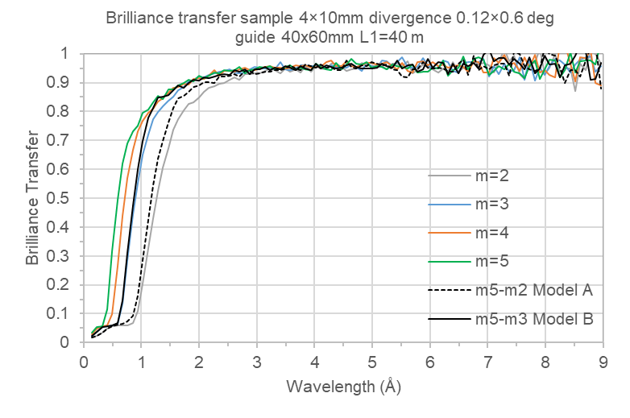
Model A
Model B
(a)
(b)
(c)
(d)
Fig. 7. (a) Brilliance transfer of the straight elliptic guide using various guide coating. (b) & (c) Non-uniform elliptic guide coating distribution profiles. (d) Brilliance transfer of the elliptic guide using the coating distribution profiles in comparison with uniform coatings.
- Performance
Fig. 8a shows the resolution function of eMAP in comparison with ENGIN-X. The resolution data were derived from fitting selected CeO₂ Bragg peaks produced in the simulations. The diffraction resolution of eMAP, operating at 0.12°×0.4° HWHM divergence, is about 0.3% while ENGIN-X has a resolution of ~0.25%. Data points at λ<1 Å are not shown due to relatively low Bragg peak intensities from the simulations. Fig. 8b shows the FOM of eMAP surpasses ENGIN-X by more than a factor 10 at higher λ while achieving about a factor 4 at λ<2.5 Å. The FOM of ENGIN-X running at 25 Hz was used in this comparison because this mode is optimal for macroscopic strain scanning in most engineering materials [2].
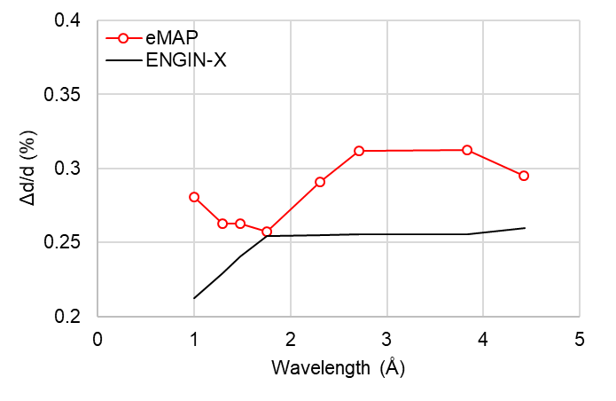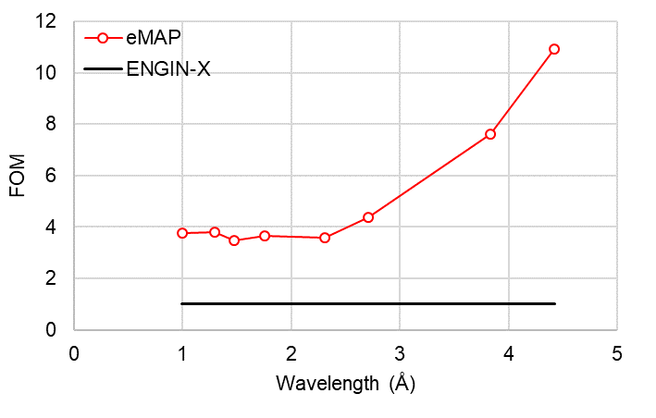
(a)
(b)
Fig. 8. Comparison in performance between eMAP and ENGIN-X. (a) Resolution function of both instruments. (b) Gain in figure of merit on eMAP compared to ENGIN-X (operating at 25 Hz).

At Δd/d=0.31% (at 2.7 Å), the integrated flux in the full λ bandwidth on eMAP is about 1.2×10⁶ n.cm⁻².s⁻¹. A uniform 4×10 mm² beam at sample position can be defined using the small divergence in this mode (see Fig. 9). The flux profile of eMAP shows higher flux than ENGIN-X throughout the λ range. This is reflected in the simulated CeO₂ diffraction patterns showing the Bragg peak intensities are up to a factor 5 higher on eMAP. The vertical divergence can be increased by tuning the vertical gaps of the slits to double the flux to about 2.5×10⁶ n.cm⁻².s⁻¹ at Δd/d=0.39% (at 2.7 Å). Bragg peak intensities on eMAP in this mode are almost a factor 10 higher than ENGIN-X. Though the beam becomes less uniform in the vertical direction due to increased divergence (see Fig. 10), the improved time resolution in this ‘high flux’ mode is crucial for studying short-timescale phenomena such as those occurring in in-situ loading measurements where beam uniformity is not a critical requirement.
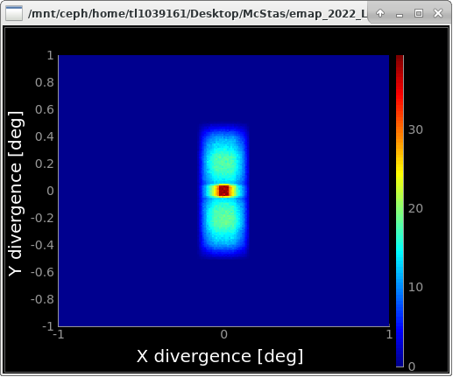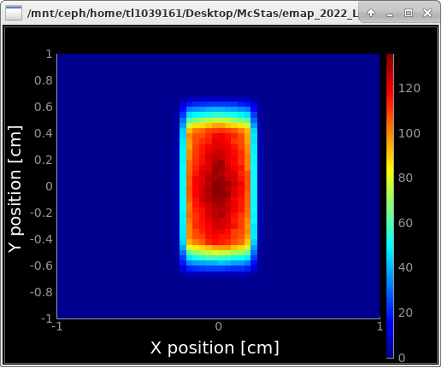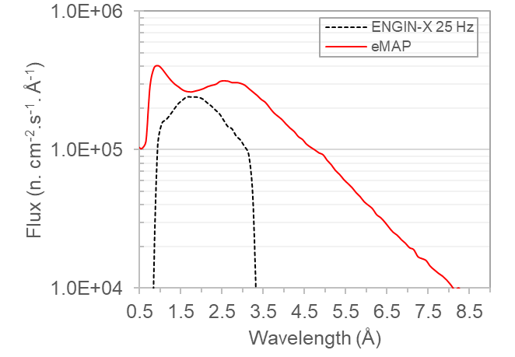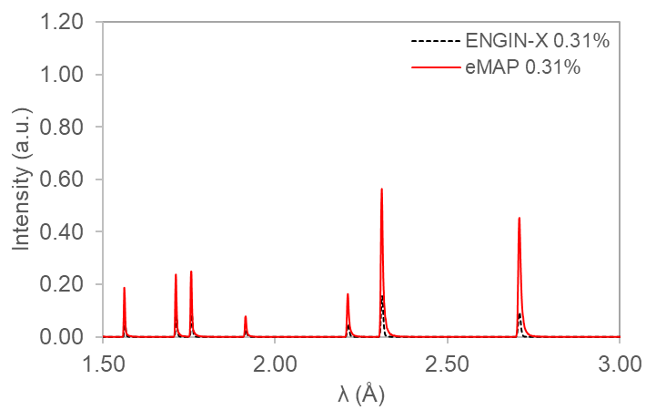
Divergence profile at sample
Beam profile at sample
Fig. 9. The simulated flux, divergence, beam profile at sample position, and CeO₂ diffraction pattern on eMAP at Δd/d=0.31% (at 2.7 Å). Simulated flux and diffraction pattern on ENGIN-X (operating at 25 Hz) at the same resolution are shown for comparison.
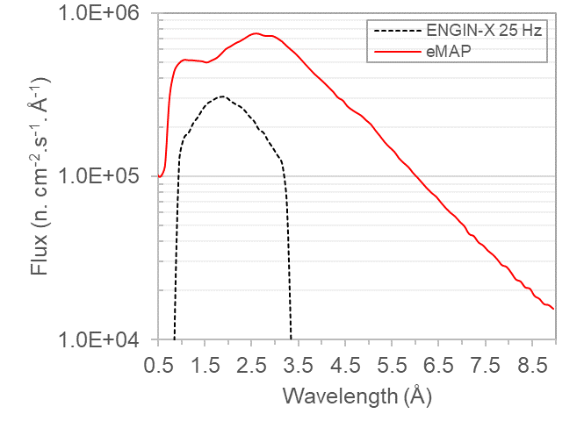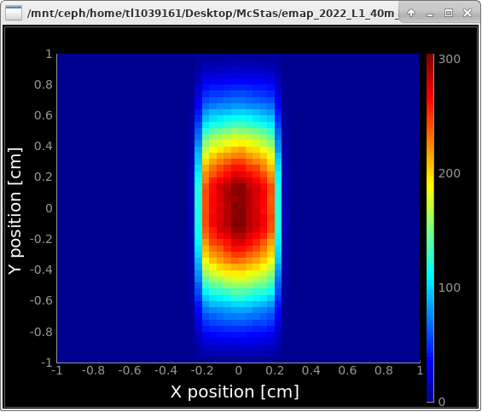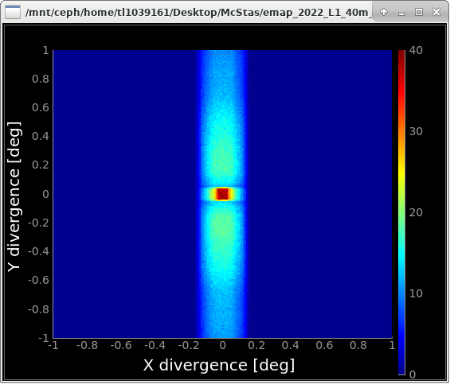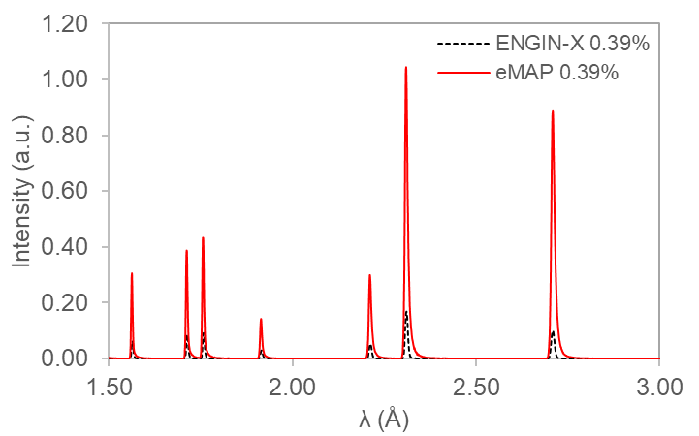
Divergence profile at sample
Beam profile at sample
Fig. 10. The simulated flux, divergence, beam profile at sample position, and CeO₂ diffraction pattern on eMAP at Δd/d=0.39% (at 2.7 Å). Simulated flux and diffraction pattern on ENGIN-X (operating at 25 Hz) at the same resolution are shown for comparison.

Fig. 11 shows a comparison of the performance of eMAP with several world-leading time-of-flight engineering diffractometers [11-14]. Flux data from other instruments at a diffraction resolution comparable to eMAP are shown. It should be noted that data of other instruments may correspond to different wavelength intervals because of the different lengths and source frequencies. At ISIS, ENGIN-X will serve as the main instrument for high resolution (Δd/d=0.25%) engineering materials studies while IMAT will provide high flux at more modest resolution (Δd/d=0.7%). The performance gap between them will be addressed by eMAP which will be the high flux medium resolution (Δd/d=0.3-0.4%) instrument. The user programme at ISIS for engineering diffraction will benefit from the availability of a selection of instruments that encompass a larger range of resolution and flux to increase the range of industrial problems that can be studied. Nevertheless, ISIS instruments work with a lower source brilliance and lower time-averaged neutron flux than many of the diffractometers at other sources.
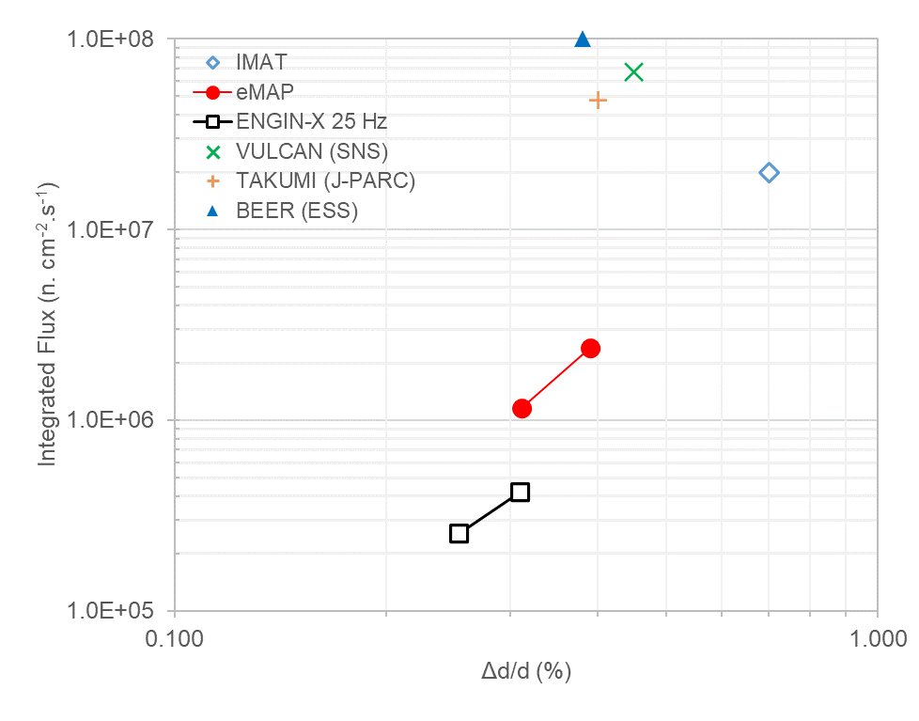
ISIS
Fig. 11. Integrated flux at sample position as a function of diffraction resolution for eMAP. Data available for BEER (ESS) [11], VULCAN (SNS) [12], TAKUMI (J-PARC) [13], IMAT [14] and ENGIN-X (25 Hz) are shown for comparison.
- Summary
eMAP is the new proposed high flux medium resolution engineering diffractometer that will be built at ISIS Target Station 2. Monte Carlo simulations were performed to optimise the straight elliptic neutron guide to achieve a brilliance transfer of >90%. The diffractometer achieves a figure of merit that surpasses the ENGIN-X diffractometer at ISIS by more than a factor 10. eMAP has a diffraction resolution of about 0.3% (at 2.7 Å) and integrated flux in the full wavelength bandwidth of ~9 Å is 1.2×10⁶ n.cm⁻².s⁻¹. It features great flexibility in increasing vertical divergence to double the flux at a diffraction resolution of about 0.4%. The new instrument will bring additional capacity and advanced stress measurement capabilities to the engineering diffraction user programme at the ISIS neutron and muon source.

This work was supported by the Science and Technology Facilities Council (UK). TLL would like to thank the ISIS Neutron and Muon Instrument Development Group for the valuable discussions and suggestions on the instrument design. The authors are grateful to the ISIS Neutronics Group who provided the moderator files used in the simulations.

References
- https://www.isis.stfc.ac.uk/Pages/Endeavour.aspx (Last accessed on 5 February 2023)
- J.R. Santisteban, M.R. Daymond, J.A. James, L. Edwards, J. Appl. Crystallogr. 39(6), 812-825 (2006)
- W. Kockelmann, et al., J. Imaging 4(3), 47 (2018)
- W. Kockelmann, et al., Status of the neutron imaging and diffraction instrument IMAT, in Proceedings of the 10th World Conference on Neutron Radiography, Phys. Procedia 69, 5-10 October 2014, Grindelwald, Switzerland (2015)
- M.R. Daymond, Physica B 301(3-4), 221-226 (2001)
- M.W. Johnson, L. Edwards, P.J. Withers, Physica B 234, 1141-1143 (1997)
- M.W. Johnson, M.R. Daymond, J. Appl. Crystallogr. 35(1), 49-57 (2002)
- P.K. Willendrup, K. Lefmann, J. Neutron Res. 22(1), 1-16 (2020)
- https://isisneutronmuon.github.io/mcstas/How-to-Use-the-ISIS-moderator-component (Last accessed on 5 February 2023)
- L.C. Chapon, et al., Neutron News 22(2), 22-25 (2011)
- J. Fenske, et al., BEER – The Beamline for European Materials Engineering Research at the ESS, in Proceedings of the 6th European Conference on Neutron Scattering, J. Phys.: Conf. Ser. 746(1), 30 August – 4 September 2015, Zaragoza, Spain (2016)
- X-L. Wang, et al., Physica B 385, 673-675 (2006)
- S. Harjo, Nihon Kessho Gakkaishi 50(1), 40-45 (2008)
- W. Kockelmann, et al., IMAT – a new imaging and diffraction instrument at ISIS, in Proceedings of the 7th International Topical Meeting on Neutron Radiography, Phys. Procedia 43, 16 – 24 June 2012, Kingston, Canada (2013)

Corresponding author: Tung-lik.lee@stfc.ac.uk

