The TAS-IN8 upgrade: towards the limit of a three-axis spectrometer performance
Andrea PIOVANO and Alexandre IVANOV*
Institut Max von Laue – Paul Langevin, 71 avenue des Martyrs, CS 20156, 38042 Grenoble Cedex 9, France
Abstract. IN8 is a high-flux three-axis thermal neutron spectrometer designed to measure inelastic neutron scattering on single crystals in a wide energy and momentum transfer range. It is the highest thermal flux spectrometer worldwide with the monochromatic flux at the sample up to 10⁹ neutrons/cm²/s where users can perform demanding experiments not possible anywhere else. In recent years, the IN8 spectrometer has undergone several major upgrades that have further extended the capabilities of the instrument to the limits achievable with the standard setup. The first part of the upgrade was centred on the replacement of the monochromator assembly, now consisting of four double focusing reflecting crystal faces with enhanced luminosity. The ensuing upgrade was to replace the entire secondary spectrometer. As the result, the new spectrometer, called Thermes, profits from a compact design and it is well shielded against ambient experimental background. All the incorporated modifications have given the instrument an unprecedented and unique luminosity combined with an optimal signal-to-noise level and a remarkable configuration flexibility for a broad range of experimental requirements.

1 Introduction
Three-axis spectroscopy (TAS) is a well-known and widely used technique for the study of excitations in condensed matter. An introduction to the TAS technique can be found in many textbooks and an ample review on the principles as well as technical aspects is given in Ref.[1].
TAS is the technique of choice whenever it is desirable to explore specific regions in the excitations phase space of a material under study defined by their momentum Q and energy E. The relevant quantities for a TAS instrument are luminosity, resolution and signal-to-noise ratio. Since the inelastic neutron scattering signal is intensity limited even at the neutron sources with highest brilliance, a spectrometer ‘‘flexibility’’ is an important issue: it means being able to trade in the most practical way resolution against luminosity.
The recent upgrade of the thermal three-axis spectrometer IN8 at the Institut Laue-Langevin (ILL) [2,3] aimed to optimise its experimental capacities. In the following we will summarise the characteristics of the new instrument and highlight its enhanced performance in terms of flexibility and luminosity. We will discuss its scientific impact and present the prospective steps to be taken for further improving the instrument.

2 Primary spectrometer
In order to boost the performance of the primary spectrometer we have designed and implemented a new monochromator assembly (Fig.1 and 2), making use of experience in the engineering of multi-crystal arrays with remotely controlled two-dimensional (horizontal and vertical) variable focusing accumulated over the last decades.
The new device includes four crystal faces that can be alternatively set in Bragg reflection: mosaic pyrolytic graphite and copper crystals with reflecting planes PG002 and Cu200, as well as elastically bent perfect silicon crystals [4,5] with reflecting planes Si111 and Si311 both eliminating the second order diffraction harmonics.
The mosaic crystal faces are composed of 121 individual crystals each, organized in 11 horizontal rows and 11 vertical columns for a total active surface of about 290 x 200 mm² (horizontal x vertical). The two silicon crystal faces, instead, are built as a combination of 11 cassettes, piled up in the vertical direction for a total active surface of 230 x 200 mm² (horizontal x vertical) and filled in with stacks of thin silicon blades assembled to be bent in the horizontal plane within the elastic bending limits. A system of precise camshafts is designed for each face in order to incline individual crystals of the mosaic crystal faces or the cassettes of the silicon faces and bend the silicon blades in these cassettes. With only two motor/encoder pairs per crystal face, we achieve both vertical and horizontal bending, creating the desired approximation of a chosen ideal focusing surface. This functionality enables independent adjustments of the bending radius in each direction.

FIG. 1. General view of the new monochromator assembly
with the PG002 crystal face in working position.
Unexposed faces are hidden by neutron shielding.

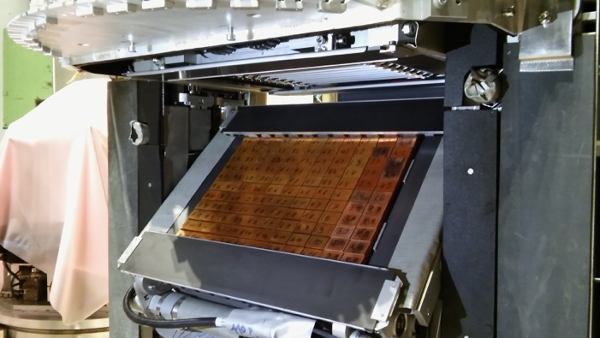

FIG. 2. The copper crystal face during the cycle of
changing over between different working faces

Adding the fourth Si311 face permitted enhancement of the instrument performance at low energy transfers and provided additional flexibility for high-resolution experiments [6]. We found a possibility to include the fourth reflecting face through the original design of back-to-back arrangement of the two pairs of the reflecting faces with a smart lifting and face exchange system. The duration of the changing cycle between different faces varies from a minute to a few minutes scale depending on the crystal face to be put in the working position: exchange between silicon and mosaic faces involves an additional vertical translation (Fig.2). The collected experience in face exchange cycles demonstrates high stability and reliability of the exchange system with well reproducible settings after bringing a chosen face to the working position so that no additional alignment is required.
The actual compact structure provided additional space to extend the lateral dimensions of each crystal face by more than 20% enabling a better use of the available white beam divergence. The design of the assembly allows for dismounting of any of the 4 faces (for maintenance etc.) and any combination of them so that the remaining subset of the faces can continue to work. Each reflecting face is thoroughly protected with neutron absorbing materials (Cd, sintered boron carbide with ¹⁰B enrichment) behind the crystals and around the whole face in order to reduce parasitic scattering from the construction materials, cables, electrical connectors etc. and to decrease their residual activation after exposure to the neutron beam. For the same purpose, the exchange between reflecting surfaces in the course of experiment without closing the neutron beam from reactor is fulfilled at a special rotation position of the whole monochromator drum when the entrance window for the white beam is shut with a dedicated local beam-stop.

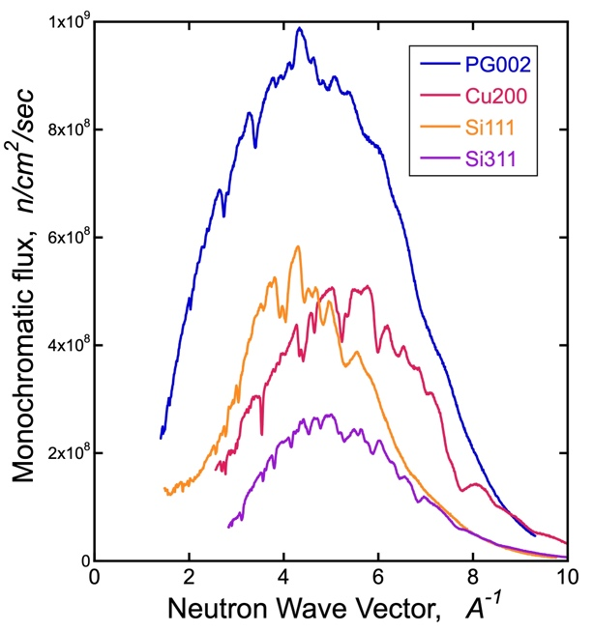

FIG. 3. The flux of monochromatic neutrons at the sample
position for all 4 faces of the new IN8 monochromator.
The take-off angle on the monochromator can be varied in
the range 10-90 degrees.

The new monochromator outperforms the previously used device with 3 crystal faces [3]. Flux measurements (Fig.3) indicate an increase in the monochromatic flux at the sample position by 40 to 60% depending on the reflecting face and the wavelength range compared to the previous primary spectrometer. Correspondingly, the background conditions have been improved by about 20 to 40% through the careful choice of neutron shielding components. An additional set of Soller slit collimators in white and monochromatic beam with ¹⁰B-enriched coating and better stability in the intense radiation field enhances the instrument flexibility in high-resolution configurations. The change of collimators and open tunnel in white beam is controlled remotely. The monochromator performance has been confirmed after the recent ‘in-pile’ beam-tube exchange, now with a slightly reduced diameter of its extremity nose in the heavy water moderator of the ILL high-flux reactor.

3 Secondary spectrometer
With the aim to keep the IN8 to the highest standards of efficiency and as the reference instrument among high-flux thermal TAS instruments, we have engaged in another project of developing a new single-detector secondary spectrometer called ThermES (as abbreviated from Thermal Excitation Spectra, Fig.4).

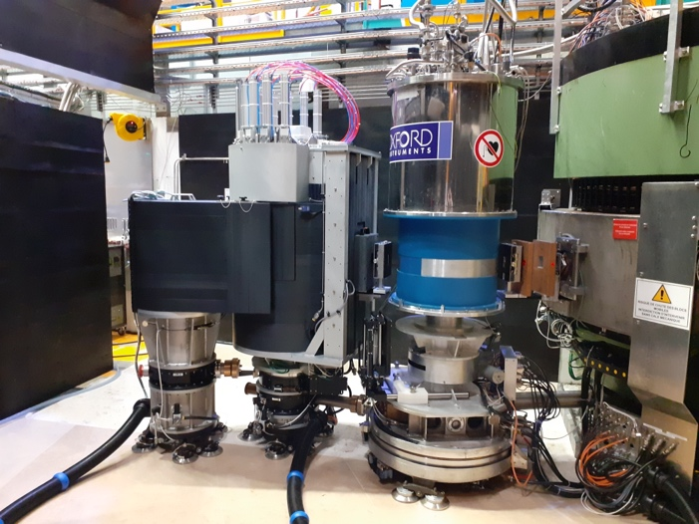

Fig. 4. The brand-new Thermes spectrometer in the IN8
zone during the first working cycle, here at an experiment
with a vertical field superconducting cryomagnet.

Thermes has a compact design and optimized neutron shielding to minimise all parasitic background not coming from the sample or passing away from the principal optical path. While most of the background in an IN8 experiment is typically stemming from the sample itself and its nearest environment (cryostat etc.), the signal-to-noise ratio could be anyway improved due to thoroughly arranged neutron shielding environment. An additional gain in high-resolution setup is brought in by the new enriched boron coated slit collimators and by thorough design of their neutron shielding. This permitted to eliminate major sources of background leaking into the zone around the analyser crystals.
The analysers in use (Fig.5) are presented by the double-focussing devices built from mosaic crystals of pyrolytic graphite (reflection plane PG002) and copper (reflection plane Cu200) and also elastically bent perfect silicon crystals (reflection plane Si111). The mechanical design and implementation of neutron beam focussing in the analysers is similar to that of the corresponding monochromator faces. The size of active reflection area on the analysers is about 180 x 140 mm² (horizontal x vertical). The smaller dimensions of the analysers respect the closer distance from the analysers to the sample than from the sample to the monochromator so that the resolution contributions from both energy selective units match each other. Changing over between different analysers is done manually, removing one and installing the other one at place. Accuracy in the manual re-positioning is sufficiently high with no change in translation, tilt and focussing alignment.

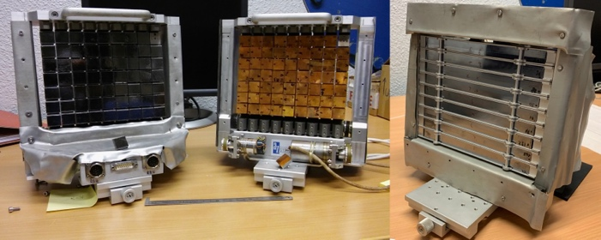

Fig. 5. Double-focusing analysers of the Thermes:
pyrolytic graphite (PG002, left), copper (Cu200, centre)
and elastically bent silicon (Si111, right) crystals.

The classical single-detector configuration of Thermes is enriched with a diaphragm positioned next to the Helium-3 counter. This diaphragm permits variation of the sensitive area of the neutron counter and helps optimising the signal-to-noise ratio in the experiments with diverse sample sizes.
The new spectrometer proposes a larger dynamical range with respect to the previous setup, especially towards high values of momentum transfer or high scattering angles, now possible up to at least 120 degrees in both scattering directions. This is an advantage for lattice dynamics studies, now again highly demanded at IN8-Thermes along with research in magnetism.
The new compact design opens route for the use of the highest available magnetic fields previously restricted due to insufficient space required to reduce attraction power from stray fields resulting in considerable forces acting on the superconducting magnet.
The secondary spectrometer is equipped with two oriented pyrolytic graphite filters each of about 5 cm in thickness. As a rule, one is positioned in the scattering beam in order to suppress high-order harmonics scattering from the monochromator and/or analyser crystals that can create a substantial parasitic signal, in particular in combination with mosaic crystal faces. The second filter can be installed when required in order to enhance the filtering power. The particular combination of silicon monochromator together with silicon analyser creates a specifically “clean” set-up where the filters can be removed. This compensates inevitable reduction in total reflected intensity and offers comfortable freedom in the chosen neutron energy that can be different from discrete values imposed by the filter.
Due to its modular structure the Thermes secondary spectrometer can be replaced with the FlatCone multi-analyser spectrometer [7]. The sample table remains basically unchanged in the undertaken instrument upgrades.

4 Available sample environment and programmed improvements
We operate two dedicated liquid-He (“wet”) cryostats in the temperature range 1.5-320K. One is the standard ILL orange cryostat with the bore for inserting sample with a diameter of 49 mm. The other cryostat offers enlarged bore of 69 mm for relatively bulky sample arrangements combined from several co-aligned single crystals. Both cryostats are equipped with multiple capillary He pumping system working with the regulated “cold-valve” and correspondingly powerful heaters permitting a relatively fast cooling/heating cycle (about 1-1.5 hour for the whole temperature range).
A particular sample environment that is available on Thermes includes the VacBox cryostat designed to work with the background reducing diaphragms maximally approached to the sample. The adjustable diaphragms and ‘in-box’ (that is in the vacuum-pumped neutron path) rotating tunnels are made from the boron-containing materials and are positioned only a few centimeters away from the sample. This configuration is optimized for relatively small samples (less than 10 mm in any direction) when the background conditions are especially demanding. In the VacBox the sample stick is rotating independently of the cryostat using an additional rotation stage in a way similar to that applied to the vertical field cryomagnets. This equipment is compatible with the Goniostick sample alignment device developed at the ILL [8].
Most of the other sample environment equipment available at ILL can be used on Thermes such as standard cryo-furnaces, high-field cryomagnets (currently the maximum authorized field is at 11 Tesla), high-pressure in the Paris-Edinburg press (at ambient and low temperature) with pressures at sample up to 100 kbar, high-temperature furnaces (up to 1600 ºC).
We are considering further improvements to be implemented in the near future as the most necessary
evolution of the instrument. One of them is a set of remotely controlled compact non-magnetic diaphragms operated in the presence of the cryomagnet’s stray fields. The other is a ‘dry’ cryostat (a closed cycle refrigerator) combined with a cradle permitting fast reorientation of the sample crystal plane without removing the sample from the cryostat.
We are studying the potential advantages of working with a cold beryllium filter in combination with the pyrolytic graphite analyser in view of high-resolution studies of vibration dynamics of protonated molecules. The feasibility of Brillouin neutron scattering experiments is being reviewed with the new set of fine slit collimators and a dedicated vacuum box to reduce air scattering. A more distant project of mechanical velocity selector for Thermes awaits for outcome from the other thermal neuron spectrometers that now begin working with such a delicate and budget demanding equipment.

5 Scientific Impact

The new spectrometer started working at full capacity after commissioning and has been operating for the user community for about two years so far. Studied materials range from complex oxides with specific magnetic and structural properties to various novel superconductors, metals and semiconductors with peculiar electron spectra. Corresponding publications begin to appear [6,9-12].

Here we want to highlight particular success of experiments where accomplished developments had a direct impact on the quality of the collected data.

Matsuura et al [10] have explored the phonon renormalization effects accompanying the ‘6 K anomaly’ in the quantum spin liquid candidate κ-(BEDT-TTF)₂Cu₂(CN). Such a system is extremely difficult to synthesize in the form of large single crystals therefore a set of smallish crystals of only 26 mg total mass was assembled for this study. The improved signal-to-noise performance of the new spectrometer finally allowed identification of the desired effect based on this capability that remains unique to IN8-Thermes spectrometer.
Xie et al [11] studied a Kagome lattice compound CsV₃Sb₅ that exhibits intertwined charge density wave (CDW) order and superconductivity. The experiments on Thermes with the sample built from 400(!) co-aligned single crystals demonstrate that the CDW order in this compound is associated with a static lattice distortion and a sudden hardening of an optical phonon below the ordering transition. The results indicate the effect of wave vector dependent electron-phonon coupling is playing an important role in the CDW order.

These and other examples of the stable and reliable operation ensure fruitful outcome in the ILL user program.

6 Conclusions
We have optimized the IN8 spectrometer for the easiness and comfort of operation, faster change of configurations and maintenance to minimize dead times. IN8-Thermes at ILL with unrivalled performance continues to supply the highest monochromatic flux among all thermal three-axis spectrometers worldwide. The instrument is dedicated to inelastic neutron scattering measurements with energy transfers in the range of from one to about one hundred meV, it is used to investigate thermal spectrum range of magnetic excitations and lattice vibrations. Its high incident flux offers a wide range of flexibility for optimizing the intensity versus resolution conditions and permits investigations of small samples and weak inelastic response not possible elsewhere. The enhanced

References
- G.Shirane, S.M.Shapiro, J.M.Tranquada, Neutron Scattering with a Triple-Axis Spectrometer, Cambridge University Press, Cambridge (2002).
- A.Hiess, R.Currat, J.Saroun, F.J.Bermejo, Physica B 276-278, p.91-92 (2000).
- A.Hiess, M.Jimenez-Ruiz, P.Courtois, R.Currat, J.Kulda, F.J. Bermejo, Physica B 385-386, p.1077-1079 (2006).
- P.Mikula, J.Kulda, P.Lukas, M.Ono, J.Saroun, M.Vrana, V.Wagner, Physica B 283, p.289-294 (2000).
- J.Kulda, J.Saroun, NIMA 379, p.155-166 (1996).
- T.Tejsner, A.Piovano, A.Tutueanu, A.T.Rømer, B.O.Wells, J.Grivel, M.Boehm, L.Udby, Phys. Rev. B 101, p.100504(R) (2020).
- M.Kempa, B.Janousova, J.Saroun, P.Flores, M.Boehm, F.Demmel, J.Kulda,
Physica B 385–386, p.1080–1082 (2006).
- E.Lelièvre-Berna, E.Bourgeat-Lami, J.Allibon, P.Decarpentrie, J.-P.Gonzales, J.Halbwachs, J.Ollivier, B.Ouladdiaf, J. Neutr. Res. 19, p.27–32 (2017).

performance, reliability and flexibility of IN8-Thermes constitute a major step forward to the successful functioning for the ILL user program. The present instrument state together with planned improvements ensures the instrument operation in the years to come. Current information about the instrument and additional details of the available configurations and operation can be found on the instrument webpage [13].

We acknowledge the unvaluable help from all the ILL services whose cooperation made it possible to realize the whole project. We particularly thank Franck Charpenay and Stephane Roux for their technical and engineering assistance as well as all helpful discussions, advices and recommendations from our colleagues Jiri Kulda and Martin Boehm.

- A.S.Sukhanov, Y.V.Tymoshenko, A.A.Kulbakov, A.S.Cameron, V.Kocsis, H.C.Walker, A.Ivanov, J.T.Park, V.Pomjakushin, S.E.Nikitin, I.V.Morozov, I.O.Chernyavskii, S.Aswartham, A.U.B.Wolter, A.Yaresko, B.Büchner, D.S.Inosov, Phys.Rev.B, 105, p.134424(1-13) (2022).
- M.Matsuura, T.Sasaki, M.Naka, J.Müller, O.Stockert, A.Piovano, N.Yoneyama, M.Lang, Phys.Rev.Res., 4, p.L042047(1-6) (2022).
- Y.F.Xie, Y.K.Li, Ph.Bourges, A.Ivanov, Z.J.Ye, J.-X.Yin, M.Zahid Hasan, A.Y.Luo, Y.G.Yao, Zh.W.Wang, G.Xu, P.Ch.Dai, Phys.Rev.B, 105, p.L140501(1-6) (2022).
- K.J.Neubauer, F.Ye, Y.Shi, P.Malinowski, B.Gao, K.M.Taddei, Ph.Bourges, A.Ivanov, J.-H.Chu, P.Ch.Dai, NPJ Quantum Mat., 7, p.112(1-8) (2022).
- www.ill.eu/users/instruments/instruments-list/in8/description/instrument-layout

