Symmetry breakings and resulting magnetic, electric, and optical properties in ferroic materials

Tsuyoshi Kimura
Dept. of Advanced Materials Science, University of Tokyo, tkimura@edu.k.u-tokyo.ac.jp, Japan
The symmetry breaking ascribed to the evolution of an order parameter is one of the most important concepts in materials physics. Representative examples are symmetry breakings in “ferroic” materials such as the symmetry breaking of time reversal in ferro-magnets and that of space inversion in ferro-electrics. Thus, one can find that this concept contributes to not only fundamental science but also materials’ functionalities available for device applications. Furthermore, recent research developments of “multiferroic” materials with broken time-reversal and space-inversion symmetries have triggered extensive studies on unconventional ferroic materials such as “ferro-toroidic” and “ferro-axial” materials [1].
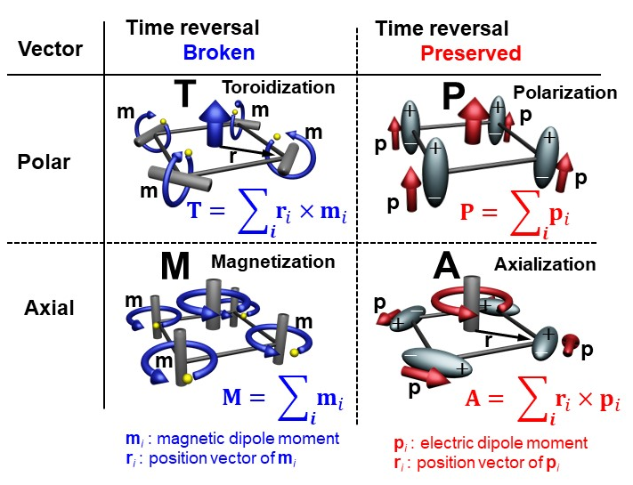
The relationships among ferro-electric, ferro-magnetic, ferro-toroidal, and ferro-axial orders are schematically illustrated in Fig. 1. In the case of ferro-toroidal order whose order parameter is a toroidal moment, that is, the sum of the cross product of spin and its position vector. Most typically, the toroidal moment is generated by head-to-tail arrangement of magnetic dipoles, which breaks both the time-reversal and space-inversion symmetries. When we replace magnetic dipoles in toroidal moment with electric dipoles, ferro-axial moment is generated. In the ferro-axial order, a rotational electric-dipole arrangement breaking some mirror symmetry, the so-called ferro-axial moment, is an order parameter.
Fig. 1 Relationships among ferro-electric, ferro-magnetic, ferro-toroidal, and ferro-axial orders in terms of symmetry breakings.
In this presentation, we show symmetry-dependent magnetic, electric, and optical phenomena characteristic of unconventional ferroic orders such ferro-toroidal, ferro-axial, and ferro-quadrupole orders. The phenomena include magnetoelectric effect [2], nonreciprocal directional dichroism [3], and electrogyration [4]. Furthermore, in general, ferroic materials bear “domain” structures, that is, spatial distributions of order parameters. However, observations of domain structures in unconventional ferroic materials are not straightforward. Here, we also show ways to spatially visualize domain structures in such unconventional ferroic materials.
This work has been done in collaboration with K. Kimura, T. Katsuyoshi, T. Hayashida, Y. Sawada, S. Kimura, Y. Uemura, S. Matsuoka, T. Hasegawa, D. Morikawa, K. Tsuda, and S. Hirose, H. Morioka.
[1] Cheong SW et al., npj Quantum Mater. 3, 19 (2018).
[2] Kimura K et al. Phys. Rev. B 97, 134418 (2018); Kimura K et al., Phys. Rev. Mater. 2, 104415 (2018).
[3] Kimura K et al., Commun. Mater. 1, 39 (2020); Katsuyoshi T et al., J. Phys. Soc. Jpn. 90, 123701 (2021).
[4] Hayashida T. et al., Nat. Commun. 11, 4582 (2020); Hayashida T et al., Phys. Rev. Mater. 5, 124409 (2021).

TK acknowledges support by KAKENHI (Grants Nos. JP19H05823 and JP21H04436).

