Elasticity of dense metal-organic framework compounds

Julia Büscher¹, Eiken Haussühl¹, Lea Pennacchioni^{1,2}, Katja Bunk¹, Victor Milman⁴, Alessandro Mirone⁵, Alexei Bosak⁵, Björn Winkler¹
¹Institute of Geosciences, Goethe University, Frankfurt am Main, Germany, buescher@kristall.uni-frankfurt.de, ²Deutsches GeoForschungsZentrum GFZ, Potsdam, Germany, ³Deutsches Elektronen-Synchrotron DESY, Hamburg, Germany, ⁴Dassault Systèmes BIOVIA, Cambridge, United Kingdom, ⁵European Synchrotron Radiation Facility ESRF, Grenoble, France

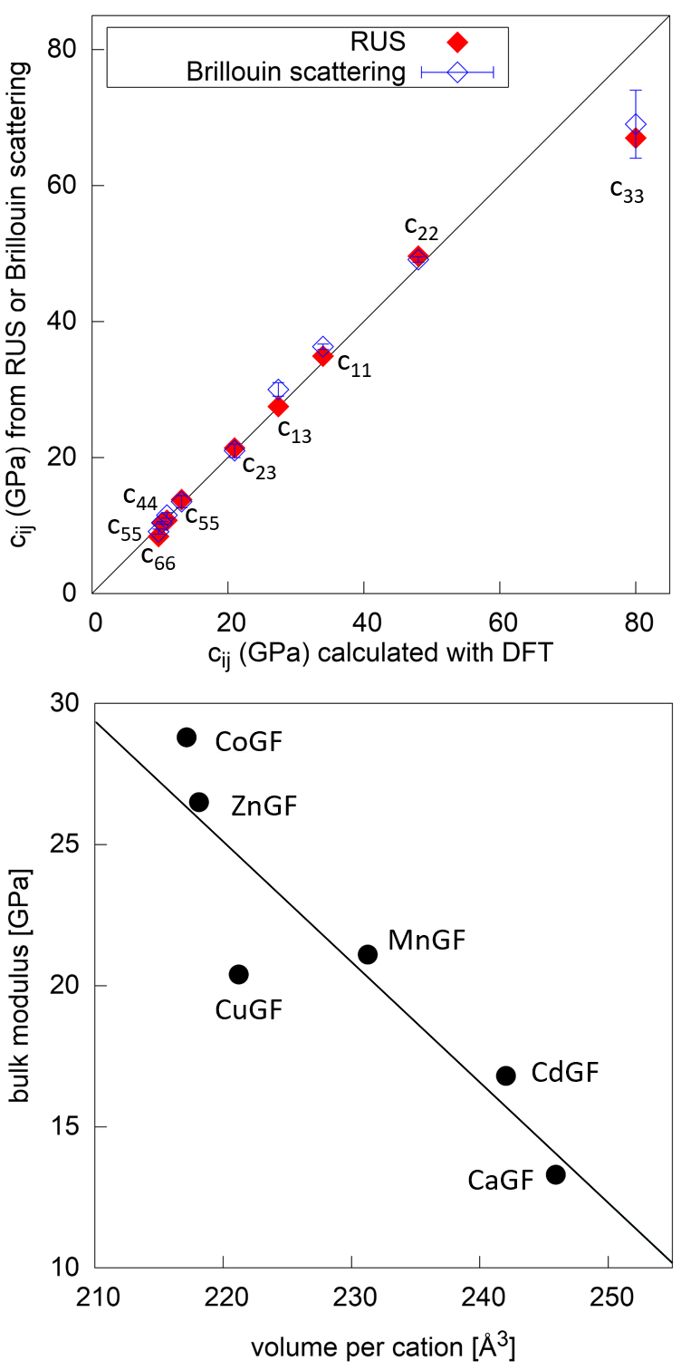
Metal-organic framework (MOF) compounds are a class of promising crystalline microporous materials containing metal ions coordinated by organic linkers. Among the various MOF structures, perovskite-like structured MOFs have attracted attention due to their chemical diversity and their potential for a number of applications, e.g. in photovoltaic energy generation [1].
In the present study, the elastic behavior of metal-guanidinium formates (MGF), where M= Cu, Zn, Mn, Co, Ca and Cd has been investigated. This is of interest as these MOFs are known to undergo magnetic and/or structural phase transitions at low temperatures [3,4,5] and their elastic stiffness tensors may provide insight into the origin of their ferroic or multiferroic behavior.
MGFs are perovskite-like MOFs. Their general formula is ABX₃, where A represents C(NH₂)₃, B is a divalent metal ion (M = Cu, Zn, Mn, Co, Ca or Cd), and X is the polyatomic linker anion, formate = HCOO⁻. The elastic properties of ZnGF, MnGF, CoGF and CuGF have been investigated by plane wave / parallel plate ultrasound spectroscopy, resonant ultrasound spectroscopy (RUS), Brillouin spectroscopy (BS), density functional theory, and the analysis of thermal diffuse scattering.
Fig.1 Top: c_{ij} for ZnGF obtained by DFT compared to those obtained by RUS and BS. Experimental values on the black line indicate perfect agreement with the results from DFT. Bottom: Bulk modulus of the MGF as a function of volume of their unit cells per cation.
Fig. 1 shows a comparison of the experimental results to DFT-results for ZnGF. There generally is a good agreement between the different techniques and the theoretical data, if dispersion-corrected DFT calculations are employed. The MGFs crystallize in different structure types, where ZnGF, MnGF and CoGF are isostructural. The structure of CuGF only differs slightly from that of ZnGF [3], while CdGF and CaGF have distinct structures [4, 5]. Our results show a systematic variation of the bulk modulus as a function of the radius of the M-cation, which leads to the conclusion that at ambient conditions the elastic behavior is mainly due to the packing density and depends little on the bonding between the M-cation and the formate.

[1] Kanemitsu Y, Handa T, Photophysics of metal halide perovskites: From materials to devices, Jpn. J. Appl. Phys. 57, 090101 (2018)
[3] Hu K-L, Kurmoo M, Wang Z, Gao S, Metal-organic perovskites: synthesis, structures, and magnetic properties of [C(NH₂)₃] [M^{II}(HCOO)₃] (M=Mn, Fe, Co, Ni, Cu, Zn), Chem. Eur. J. 15, 12050 (2009)
[4] Gao H, Li C, Li L, Wei W, Tan Y, Tang Y, High pressure and elastic properties of a guanidinium-formate hybrid perovskite, Dalton Trans. 49, 7228 (2020)
[5] Haussühl E, Bayarjargal L, Winkler B, Luchitskaia R, Büscher J, Negative thermal expansion, thermodynamic properties and T-dependent Raman scattering of a new metal-organic perovskite framework, submitted

EH and JB are grateful for funding from the DFG (HA 5137-5) BW and LP thank the DFG for funding in Wi 1232. KB thanks the GSI (Darmstadt) for financial support. BW is grateful for support through the BIOVIA Science Ambassador program.

