Crystal structure for new coordination polymer obtained via solvothermal synthesis in Berghof autoclave
Andrzej Kochelª*, Kamil Twarógª, Małgorzata Hołyńska^{b}*
ª Department of Chemistry, Wrocław University, F. Joliot Curie 14, 50 383 Wrocław, Poland
^{b}Fachbereich Chemie and Wissenschaftliches Zentrum für Materialwissenschaften, Philipps-Universität Marburg, Hans-Meerwein-Straße, D-35043 Marburg, Germany
E-mail:andrzej.kochel@chem.uni.wroc.pl (A. Kochel)
holynska@chemie.uni-marburg.de (M. Hołyńska)

Coordination polymer [Cu(2,3-pdc)H₂O]_{n} was obtained by solvothermal synthesis in a Berghof BF100 pressure reactor using QUIN (quinolinic Acid) and Cu(HSO₃)₂ as substrates. The resulting compound crystallizes in triclinic system, in a space group of , with a = 7.434(3) Å, b = 7.523(4) Å, c = 7.881(3) Å, α = 62.68(5)º, β = 79.02(5)º, γ = 78.90(5)º, V = 381.5(3) Å³, Z = 2.
The coordination sphere of the Cu²⁺ ion is filled by three symmetry-dependent 2,3-pdc ligands through 3 oxygen atoms derived from the ligand carboxyl groups (O1, O1^{ii} and O3^{i}), a nitrogen atom (N1^{i}) derived from the ligand aromatic ring, and a water molecule. The resulting environment of the Cu²⁺ ion adopts the shape of a distorted tetragonal pyramid. This polymer forms one-dimensional chains extending along [100], and the occurrence of hydrogen bonds (Table 1) stabilizes the crystal structure.
Table 1: Hydrogen bonding parameters for [Cu(2,3-pdc)H₂O]_{n} [Å], symmetry codes: (i) -x+1, -y, -z+1, z+1/2; (ii) x, y+1, z.
D-H...A | D-H, [Å] | H...A, [Å] | D...A, [Å] | D-H...A, [°]
O(1W)-H(1W)...O(4)^{i} | 0.84 | 1.84(5) | 2.64(2) | 158
O(1W)-H(2W)...O(2)^{ii} | 0.84 | 1.90(4) | 2.68(2) | 154
The figure below shows the copper(II) coordination polymer structure (II).
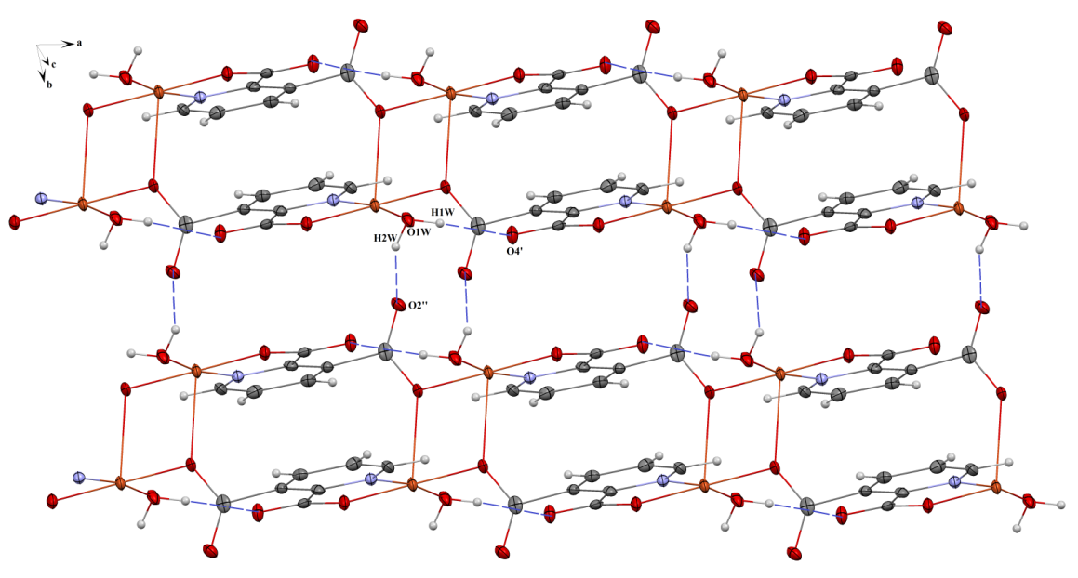
Figure 1: Copper(II) coordination polymer structure (1D).

