Uncovering novel drug targets of polyprotein precursors of SARS-CoV2

G.L.F. von Scholley¹, L. Khettabi¹, M.S. Lopez¹, R. Hillig², C. Mueller-Dieckmann¹,

E. Kandiah¹

gian-luca.freiherr-von-scholley@esrf.fr; lyna.khettabi@esrf.fr; montserrat.soler-lopez@esrf.fr; roman.hillig@nuvisan.com; christoph.mueller_dieckmann@esrf.fr; eaazhisai.kandiah@esrf.fr
¹ESRF, Grenoble, FRANCE; ²Nuvisan GMBL, Berlin, GERMANY

The current COVID-19 pandemic is caused by a novel coronavirus SARS-CoV2 (Severe Acute Respiratory syndrome-coronavirus 2). In spite of earlier outbreaks of similar coronaviruses such as, SARS-CoV and MERS-CoV, an effective therapeutic solution is not yet available for SARS - CoV2. Efforts to develop therapeutic agents to combat the spread of COVID-19 and to tackle any future pandemic outbreaks are thus urgent. This requires a greater understanding of the viral life cycle and exploration of several of the viral proteins as potential therapeutic targets.
The SARS-CoV-2 genome encodes two open reading frames (ORF) that, by ribosomal frame shifting, produce two polyproteins, pp1a and pp1ab, which are cleaved by two viral proteases to produce all the functional proteins necessary for viral replication. A papain-like protease (PLpro) cleaves the N-terminal of pp1a/pp1ab to produce the non-structural proteins Nsp1-3 while a 3C-like protease (3CLpro, also known as the main protease) cleaves pp1ab at 11 sites to produce Nsp4-16. PLpro is part of Nsp3, which also play a role in suppression of the innate immune system by its deubiquitinating and deISGlating properties. Nsp3 in combination with Nsp4 is responsible for the formation of double membrane vesicles (DMVs) with the ER-membrane, providing the environment for viral RNA replication. Nsp3 and especially PLpro is therefore an important drug target. On the immediate upstream and downstream of PLpro, a ubiquitin-binding domain, Ubl2 and a nucleic-acid binding domain, NAB, are respectively located, followed by a beta-CoV specific marker region (βSM).
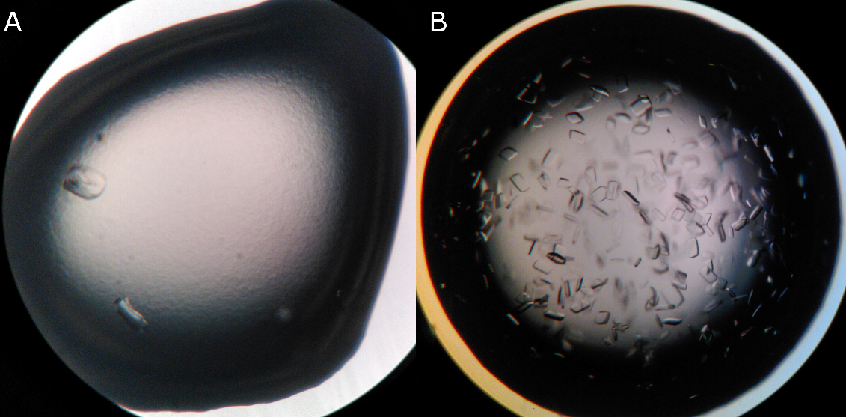
Unlike the classical approach of studying these potential drug targets as individual domain, this project aims at structural and functional studies of PLpro in the polyprotein context, targeting Nsp3 Ubl2 - PLpro - NAB, and Ubl2-PLpro-NAB-βSM in order to explore novel small molecule binding sites that might provide new leads for antiviral therapeutics. The project adopts a multi - level approach, in which molecular biology, X - ray and neutron structural methods will be combined with cryo-EM, thus integrating complementary techniques in modern structural biology.
Purification protocols for different constructs of the target domains have been developed and diffracting crystals of the Ubl2-PLpro domains have been obtained. This will then be followed by intensive fragment screening for identification of lead compounds.
Figure 1: Improvement of crystallization condition from intergrown crystals (A) to single crystals (B).

REFERENCES:
Lei, J., Kusov, Y. & Hilgenfeld, R. Antiviral Res 149, 58–74 (2018).
Serrano, P. et al., J. Virol. 83, 12998–13008 (2009).
Báez-Santos, Y. M., St John, S. E. & Mesecar, A. D. Antiviral Res. 115, 21–38 (2015).

