Diffraction Methods for MOF investigations
Jakub Wojciechowski

Triazole-based coordination compounds have been extensively investigated since the early 1980s. Several isostructural MOFs of the type [M(ta)₂], composed of octahedral M^{II} centers bridged by μ₃-bridging 1,2,3-triazolate ligands were synthesized and structurally characterized. These materials crystallize in the cubic crystal system within space group $Fd\overline{3}m$ (no. 227). In particular, [Cd(ta)₂]·3H₂O,¹ [Mn(ta)₂], [Co(ta)₂], [Zn(ta)₂], [Mg(ta)₂] and [Fe(ta)₂] were investigated.²
In contrast to isostructural compounds of the [M(ta)₂]-type, [Cu(ta)₂], which contains Jahn-Teller active Cu(II)-ions, crystallizes in the tetragonal crystal system. [Cu(ta)₂] shows a reversible phase transition from the tetragonal to the cubic crystal system within the temperature range of 120-160 °C. ³
Interestingly, [Fe(ta)₂] strongly investigated due to its high conductivity, shows wide-hysteresis high temperature spin-crossover. This reversible phase transition occurs without change of the cubic crystal system and $Fd\overline{3}m$ (no. 227) space group, which is accompanied by a large increase of the unit cell volume of nearly 22%.⁴
In many cases, single crystals of a suitable size are not accessible, or the bulk properties of a sample are of interest. In such cases, powder diffraction will provide interesting results rather than single-crystal experiments. Single-crystal diffractometers can also be employed for powder diffraction work, plus they only require micrograms of sample. Thermally activated MOFs (e.g. CFA-15)⁵ often loose crystallinity at least partially. These materials represent difficult samples for single crystal and powder diffraction, since amorphous phases is mixed with microcrystalline material. Nonetheless, crystallites have a diffraction volume large enough for structure solution and refinement.
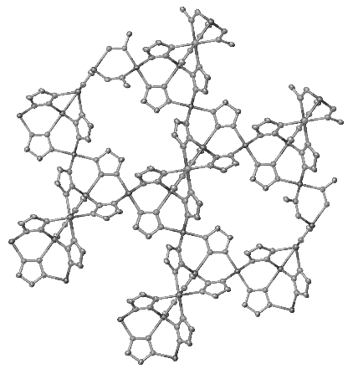
This presentation will show the results of structural characterizations of MOFs using the X-ray single-crystal and powder diffraction methods.
100 μm
sample

Figure 1. A view sample mounted on a MiTeGen loop, reconstruction of diffraction data in the reciprocal space as overview of sample quality and resulting crystal structure solution.

[1] X.-H. Zhou et al., CrystEngComm 11 (2009), 1964
[2] F. Gándara et al., Chem. Eur. J. 18 (2012), 10595
[3] M. Grzywa et al., Dalton Trans. 41 (2012), 4239
[4] M. Grzywa et al., Inorganic Chemistry 59, 15 (2020), 10501
[5] J. Fritzsche et al., Dalton Trans., 48 (2019) 15236

