Ordered and disordered binary beryllium pnictides: between Zintl polyanions and Grimm-Sommerfeld compounds
Alexander Feige¹, Laetitia Bradaczek¹, Marvin Michak¹, Daniel Günther¹, Christopher Benndorf¹, Badal Mondal², Maxim Grauer¹, Lennart Staab¹, Ralf Tonner-Zech², Oliver Oeckler¹
¹ Institute for Mineralogy, Crystallography and Materials Science, Leipzig University, Germany, research@alexanderfeige.com, ² Wilhelm-Ostwald-Institute for Physical and Theoretical Chemistry, Leipzig University
In solid-state chemistry, there is an intriguing number of binary systems lack characterization, especially in combination with the element beryllium. The limited knowledge promises a rich and unusual structural chemistry of this element.[1] The few results concerning Be pnictides include the disordered diamond-like structure of BeP₂.[2] Preliminary work based on qualitative evaluation of powder X-ray diffraction data of BeAs₂ and BeSb₂ indicates related structures for both compounds.[3] Precise structural data require very accurate diffraction data due to the large difference in scattering factors. Despite the simple stoichiometry, complete structural analysis proved difficult as the crystals obtained are much too small for laboratory data collection. We now employed a combined approach using microfocused synchrotron radiation, electron diffraction and HRTEM.
Fig. 1: Crystal structure of BeSb₂.
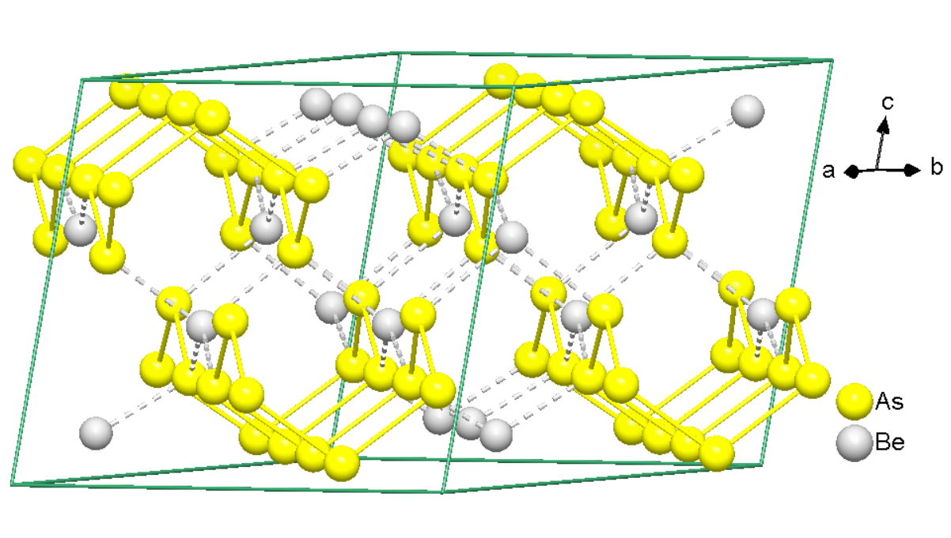
Synchrotron data of a microcrystal of BeSb₂ reveal a coloring variant of the diamond structure (Fig. 1). This tetragonal superstructure contains twisted chains of Sb atoms interconnected by Be atoms. This indicates chemical bonding according to a Zintl phase with a “sulfur-like” Sb– polyanion. BeSb₂ can also be viewed as a Grimm-Sommerfeld semiconductor with an average valence electron concentration of 4. The chemical considerations are corroborated by ab initio DFT calculations, which show that valence electron density is almost fully located on the Sb atom and thus emphasizes the Zintl ionic character.
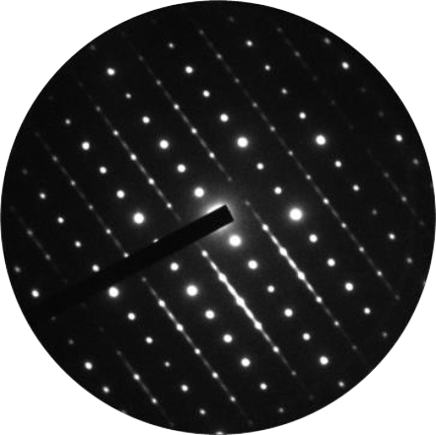
For BeP₂ and BeAs₂, our investigation confirmed the disordered diamond-like average structures from literature, which can be refined in space group I4₁/amd.[2,3] Diffraction patterns (Fig. 2) exhibit pronounced diffuse streaks that indicate stacking disorder. The evaluation of synchrotron as well as electron diffraction data reveal the local structure of ordered layers with 8-ring polyanions; idealized long range order yields a MDO polytype in the spacegroup C2/c (Fig. 3). Stacking probabilities were derived by HRTEM imaging and by simulation of diffraction patterns. The degree of ordering varies: diffuse streaks can be almost uniform but, especially in the case of BeAs₂, they also show superstructure reflections. Assuming multiple twinning, the idealized structure can be approximately refined from “single”-crystal X- ray data.
Fig. 3: Ordered structure model of BeAs₂.
Fig. 2: SAED pattern of BeP₂/BeAs₂.

[1] M. R. Buchner, R. Pöttgen, H. Schmidbaur, Z. Naturforsch. 2020, 75b, 403.
[2] P. L’Haridon, J. David, J. Lang, E. Parthé, J. Solid State Chem. 1976, 19, 287.
[3] R. Gerardin, J. Aubry, J. Solid State Chem. 1976, 17, 239.

