POWTEX: Data Reduction, Event Correlation and Machine Learning

Noah Nachtigall^{a,*}, Andreas Houbenª, Richard Dronskowskiª
ªChair of Solid-State and Quantum Chemistry, Institute of Inorganic Chemistry, RWTH Aachen University, Germany, *E-mail: noah.nachtigall@ac.rwth-aachen.de
While anticipating the commissioning of the high-intensity time-of-flight neutron powder-diffractometer POWTEX [1, 2], great efforts were made to optimally exploit the instrument characteristics for future multidimensional Rietveld refinements. The first test data were acquired at the POWGEN instrument of the SNS (Oak Ridge National Laboratory) but using a small segment of the tailor-made POWTEX detector. The raw-data reduction was challenging, and the instrument description required careful attention, as it was a one-of-a-kind experimental set-up.
This thesis focuses on three selected subtopics: the optimization of raw data reduction, thereby proving the transition to an asymmetric profile description to be necessary and successful, and two additional approaches, to be addressed below.
POWTEX’s tailor-made volume-detector is actually a four-dimensional detector registering neutron events with their position (x, y, z) and time. As an improvement to conventional surface- or grid-detectors, this allows for further data-treatment possibilities. One idea, namely event correlation, is to identify neutron events belonging to the same neutron trajectory such that the trajectories can be projected to the origin of the neutrons. By doing so, neutron events not belonging to the sample but originating from the sample environment, for example, can be nicely separated. In this preliminary work, we managed to visibly reduce the background noise of the data. We further aim to refine these findings and merge the idea with the conventional data-reduction procedure.
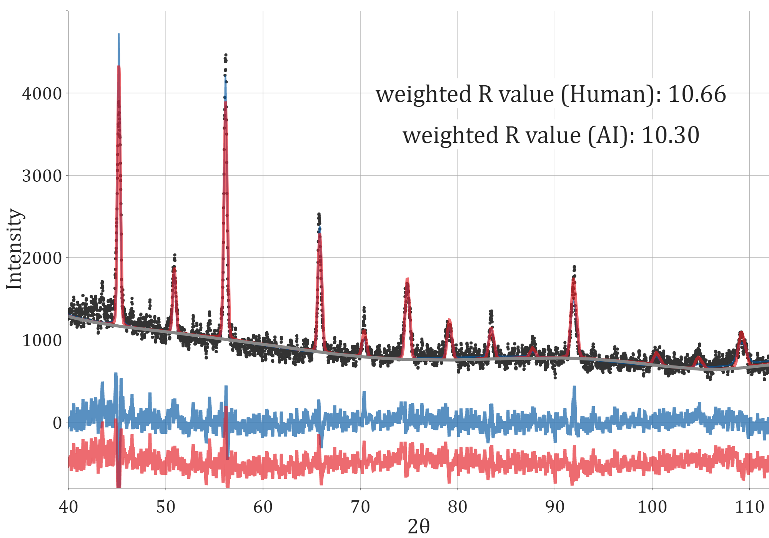
Next to the data reduction, the field of angular- and wavelength dispersive Rietveld refinement was also addressed. The data refinement obtained with the latest generation of neutron instrumentation is technically far more demanding and complex, so the user requires a solid knowledge of how to operate current diffraction-analytic software. This sparked an interest in automating the refinement process and combining the ever-growing field of machine learning with the well-established Rietveld procedure. With this objective in mind, a framework was created to use a machine-learning algorithm as an automatic decision maker in controlling Rietveld refinement within GSAS-II [2]. In the context of this work, we adequately and automatically refined simple but low-quality real-world diffraction samples without any human input (Fig. 1).
Fig. 1: Calculated and observed intensity of a Rietveld refinement guided by a human (blue) and an AI (red).
[1] Conrad H., Brückel T., Schäfer W., Voigt J. POWTEX - the high-intensity time-of-flight diffractometer at FRM II for structure analysis of polycrystalline materials. J. Appl. Cryst., 41, 836–845 (2008)
[2] Houben A., Schweika W., Brückel T., Dronskowski R. New neutron-guide concepts and simulation results for the POWTEX instrument. Nucl. Instrum. Methods Phys. Res., 680, 124–133 (2012)
[3] Toby B. H., Von Dreele R. B. GSAS-II: the genesis of a modern open-source all purpose crystallography software package. J. Appl. Cryst., 46, 544–549 (2013)

