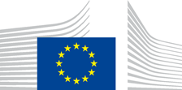 | EUROPEAN COMMISSION  JOINT RESEARCH CENTRE  Directorate G – Nuclear Reactor Safety and Security  Unit G.I.4 | 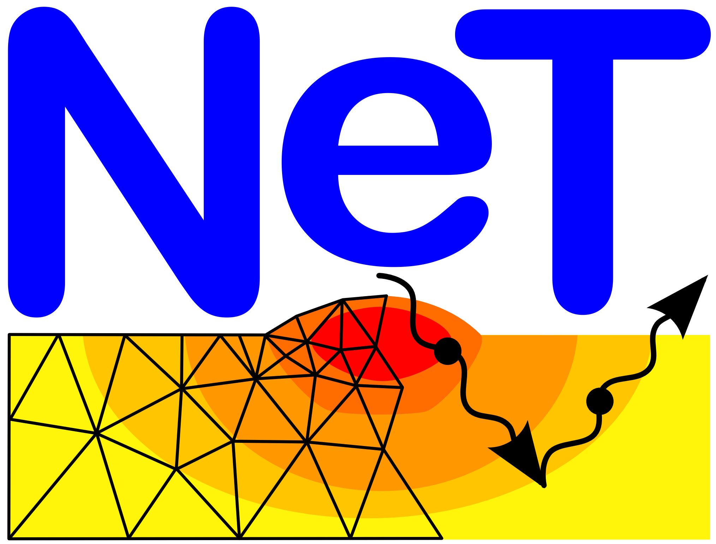

Petten, Oct 13, 2022
G.I.4/CO/co/2022.012

NeT

Network on Neutron Techniques Standardization
for Structural Integrity

41st NeT Steering Committee Meeting

TU Munich, Garching Campus, Germany, 24-25 Nov 2022
(hybrid meeting option probably available)

Draft AGENDA

Thursday, 24 Nov

09:00 Arrival of the participants, registration
09:20 Welcome and Introduction FRM-II, JRC
Agreement on the agenda
Presentation of the participants
Brief status overview JRC

Reports on NeT related activities, e.g.,
H2020 project ATLAS+ UoM
EASISTRESS EdF
BRIGHTNESS2 EdF

10:45 Coffee break
11:10 Other proposed and ongoing activities in the UK UoM

New projects from 2021 Euratom call JRC, all
(e.g. INNUMAT)
EERA Pilot Project Proposal SiMeW JRC
Standardization projects CEA, EdF, JRC

Any other relevant items not specific to a Task Group JRC, all

12:30 Lunch break

13:30 NeT TG8 EdF, CEA,
Framatome, UoM, JRC

15:00 Coffee break

15:30 NeT TG6 UoM, EdF

NeT TG5, updates Jacobs, UoM

17:30 Adjournement

±19:00 Dinner (self paid)

Friday, 25 Nov

09:00 Arrival of the participants

09:15 NeT TG7, update on SANS data analysis Centre for Energy Research

NeT TG9 Univ. Montp.,
Framatome,
CEA

Possible proposals for new NeT activities

10:30 Coffee break

10:50 NeT website, updates and modifications CO, all

Status ODIN database CO

Proposed survey amongst NeT partners EdF, CEA, JRC

Date and location of 42nd SCM
Presumed to be an in-person meeting
(Preferred period between 22 May and 16 June, excl. 29 May)

12:00 End of 41st SCM
12:00 Lunch

13:00 Guided tour to research reactor FRM-II
(optional, specific registration required)

